

**Arab Academy for Science, Technology and Maritime Transport**

**College of Engineering and Technology**

**Department of communication and electronics engineering**

**Department of mechanical engineering**

B. Sc. Final Year Project

**Virtual Engineering laboratories**

**Diesel Engine virtual lab**

Presented By:

Eslam Ahmed Mahmoud Eslam Hussein Abdelghany Fadwa Mamdouh

Supervised By:

Dr. Omneya Attallah Dr. Ahmed Al-Kabbany Dr. Iham Zidane

July – 2021

DEclaration

I hereby certify that this report, which I now submit for assessment on the programme of study leading to the award of Bachelor of Science in <insert title of degree for which registered>, is all my own work and contains no Plagiarism. By submitting this report, I agree to the following terms:

Any text, diagrams or other material copied from other sources (including, but not limited to, books, journals, and the internet) have been clearly acknowledged and cited followed by the reference number used; either in the text or in a footnote/endnote. The details of the used references that are listed at the end of the report are confirming to the referencing style dictated by the final year project template and are, to my knowledge, accurate and complete.

I have read the sections on referencing and plagiarism in the final year project template. I understand that plagiarism can lead to a reduced or fail grade, in serious cases, for the Graduation Project course.

|  |  |
| --- | --- |
| Student Name:  Registration Number:  Signed: ________________________  Date: 15 – 07 – 2021 | Student Name:  Registration Number:  Signed: ________________________  Date: 15 – 07 – 2021 |
| Student Name:  Registration Number:  Signed: ________________________  Date: 15 – 07 – 2021 |  |

STUDENTS CONTRIBUTION

Although your project will have a single title with all student names meaning that it is a group project; however, each student must have at least one individual part, including his own aims and objectives, tests, analysis and results verification. Each student should also exactly define his own work in the other shared parts. This individual work will be considered in final evaluation and presentation of each student.

VR Diesel Lab:

By:

Eslam Ahmed Mahmoud Elsayed

Eslam AbdelGhany

Fadwa Mamdouh

|  |  |  |
| --- | --- | --- |
| Chapter | Title | Contributors |
| 1 | Introduction | Eslam Ahmed Mahmoud  Eslam AbdelGhany  Fadwa Mamdouh |
| 2 | Related Work | Eslam Ahmed Mahmoud  Eslam AbdelGhany  Fadwa Mamdouh |
| 3 | Mechanical Design | Fadwa Mamdouh |
| 4 | VR | Eslam Ahmed Mahmoud |
| 5 | BCI | Eslam AbdelGhany |
| 6 | Conclusions and discussions | Eslam Ahmed Mahmoud  Eslam AbdelGhany  Fadwa Mamdouh |

Acknowledgment

The success of any project depends on the encouragement and guidelines provided by experts. Therefore, we would like to take this opportunity to thank those who taught us and helped us accomplish our work during our journey on this project. We would like to express our greatest gratitude and appreciation to Dr. Ahmad Al-Kabbany, Dr. Omneya Attallah, and Dr Iham Zeidan. We are speechless for their tremendous support and effort. We felt motivated and encouraged every time we met them asking for help and presenting our work. The encouragement, collaboration and support we had been receiving from all the members who contributed on this project was vital for our success. We are grateful for going through this experience under their supervision.

Abstract

Engineering is the backbone of innovation. The science of engineering has, and will continue to play a pivotal role in the advancements of almost every field, from agriculture to entertainment to education, with the facilitating technology component getting better every day in all these fields. Hence, it is quite fair if we say that teaching and studying engineering is simply “tomorrow in the making”. Nevertheless, guaranteeing the quality of engineering education is challenging, as it requires significant practical training and hands-on experience. For most of engineering departments, the required equipment for this training is significantly expensive and might not be affordable for many educational institutions. Moreover, during the COVID-19 pandemic and the lockdown all over the world, universities had to shift to distance learning which has stressed even further the remarkable role that distance learning can play in engineering education. This is particularly because lectures could be shifted to e-learning in a straightforward manner, while a viable and effective alternative to laboratories, especially those that involve expensive equipment, is still missing.

After searching and analysis of engineering laboratories it has been found that Diesel Engine labs are the perfect candidate to start with in our project. Firstly, Diesel engines are characterized by their extremely huge size and weight. It is almost impossible to afford an alternative for its labs in reality. Secondly, the extreme cost of the engine which might reach 1 million USD. Thus, providing the engine in virtual reality would be a perfect solution to cut costs down even after the pandemic. Thirdly, Diesel engine labs requires very high safety precautions which itself could be an additional cost for the institution. So, the best way to ensure student’s safety is through virtual lab that will provide them with the same learning experience without exposing them to safety issues. Finally, despite the efficiency and importance of diesel engine labs, they still lack of practicality and immersion as students see what the engine is doing and how they can control it but without a real visualization of what is going inside this huge machine. Thus, our solution is providing this extra part which would increasingly engage students into what they are learning and help them understand the basics behind each control they perform which will give them the required insight and knowledge for improvement.

Table of Contents

List of Figures 8

Table of Tables 9

**1** **Introduction** 10

**1.1 Project aim** 10

**1.2 Project objectives** 10

**2** **Related work** 11

**2** **LITERATURE REVIEW** 13

**2.1** **RELATED WORK** 13

**3** **MECHANICAL DESIGN** 16

**3.1** **INTRODUCTION** 16

**3.2** **DIESEL ENGINE DESIGN** 17

**3.3** **Piston** 18

**3.3.1** **Function** 18

**3.3.2** **Design** 19

**3.4**  **Crankshaft** 20

**3.4.1** **Function** 20

**3.4.2** **Design** 21

**3.5** **Bedplate** 21

**3.6** **Cylinder Block** 23

**3.6.1** **Function** 23

**3.6.2** **Design** 24

**3.7** **Cylinder Head** 25

**3.8** **Valves** 26

**3.9** **Camshaft** 28

**3.10** **Timing Belt** 30

**3.11** **Flywheel** 31

**4** **Virtual Reality** 33

**4.1 Introduction** 33

**4.1.1 Types of Virtual reality** 33

**4.1.2 VR Components** 35

**4.1.3 Project specifications** 37

**4.2 Unity Interface** 39

**4.3 Scene** 40

**4.4 GameObject** 42

**4.5 Transforms, Parenting and Scale** 43

**4.5.1 Parenting** 45

**4.5.2 Importance of Scale** 47

**4.6 Components** 47

**4.7 Static GameObjects** 52

**4.8 Rotation and Orientation** 54

**4.8.1 Euler angles** 54

**4.8.2 Quaternions** 55

**4.8.3 Implications for Animation** 56

**4.8.4 Unity’s Animation Window** 57

**4.8.5 External Animation Sources** 57

**4.9 Physics** 57

**4.10 Character Controllers** 66

**5** **Brain Computer Interface** 67

**5.1** **History of Brain-computer interface** 67

**5.2 Building a BCI system** 69

**5.2.1 EEG Data collection** 69

**4.2.2 Signal processing** 69

**5.2.3 Signal Segmentation** 70

**5.2.4 Feature Extraction** 71

**5.2.5 Feature selection** 71

**5.2.6 Classification** 72

**5.2.7 Model evaluation** 73

**5.3 BCI Literature review** 75

**5.3.1 EEG data collection in education** 76

**5.4 THE proposed system** 78

**5.4.1 Data collection** 78

**5.5.2 Data preparation & exploration** 80

**5.5.3 Signal processing** 82

**5.5.4 Windowing** 84

**5.5.5 Feature Extraction** 85

**5.5.6 Feature reduction and selection** 86

**5.5.7 Classification** 87

**5.5.8 Results** 87

**6** **Conclusion and future work** 91

**6.1** **Future work** 91

**REFERENCES** 93

List of Figures

[Figure ‎3‑1: Selected Workshop Diesel Engine to Design 16](https://d.docs.live.net/349e68613923de14/Desktop/final_graduation_book.docx#_Toc77101429)

[Figure ‎3‑2: The Project Designed Diesel Engine on SOLIDWORKS 17](https://d.docs.live.net/349e68613923de14/Desktop/final_graduation_book.docx#_Toc77101430)

[Figure ‎3‑3: Piston Design on SOLIDWORKS 19](https://d.docs.live.net/349e68613923de14/Desktop/final_graduation_book.docx#_Toc77101431)

[Figure ‎3‑4: Crankshaft Design on SOLIDWORKS 20](https://d.docs.live.net/349e68613923de14/Desktop/final_graduation_book.docx#_Toc77101432)

[Figure ‎3‑5: Crankshaft with 8 pistons design 21](https://d.docs.live.net/349e68613923de14/Desktop/final_graduation_book.docx#_Toc77101433)

[Figure ‎3‑6: Bedplate Design in SOLIDWORKS 22](https://d.docs.live.net/349e68613923de14/Desktop/final_graduation_book.docx#_Toc77101434)

[Figure ‎3‑7: Tapered Roller Bearing Illustration. image from Researchgate.com 23](https://d.docs.live.net/349e68613923de14/Desktop/final_graduation_book.docx#_Toc77101435)

[Figure ‎3‑8: Cylinder Block Design in SOLIDWORKS 24](https://d.docs.live.net/349e68613923de14/Desktop/final_graduation_book.docx#_Toc77101436)

[Figure ‎3‑9: Cylinder Liner Design in SOLIDWORKS 24](https://d.docs.live.net/349e68613923de14/Desktop/final_graduation_book.docx#_Toc77101437)

[Figure ‎3‑10: Cylinder Head Exploded view and assembled view in SOLIDWORKS 26](https://d.docs.live.net/349e68613923de14/Desktop/final_graduation_book.docx#_Toc77101438)

[Figure ‎3‑11: Spring valve assembled and exploded view in SOLIDWORKS 27](https://d.docs.live.net/349e68613923de14/Desktop/final_graduation_book.docx#_Toc77101439)

[Figure ‎3‑12: Valve Mechanism with Camshaft in a Cylinder Head in SOLIDWORKS 28](https://d.docs.live.net/349e68613923de14/Desktop/final_graduation_book.docx#_Toc77101440)

[Figure ‎3‑13: Part of the Camshaft Design with Cam Bearings in SOLIDWORKS 29](https://d.docs.live.net/349e68613923de14/Desktop/final_graduation_book.docx#_Toc77101441)

[Figure ‎3‑14: a) Timing Belt, b) Cam Gears, c) Timing Belt with Gears Assembly 30](https://d.docs.live.net/349e68613923de14/Desktop/final_graduation_book.docx#_Toc77101442)

[Figure ‎3‑15: Timing Belt Connecting the Crankshaft with the Camshaft 31](https://d.docs.live.net/349e68613923de14/Desktop/final_graduation_book.docx#_Toc77101443)

[Figure ‎3‑16: Flywheel Design in SOLIDWORKS 32](https://d.docs.live.net/349e68613923de14/Desktop/final_graduation_book.docx#_Toc77101444)

[Figure ‎4‑1: Unity interface 39](https://d.docs.live.net/349e68613923de14/Desktop/final_graduation_book.docx#_Toc77101445)

[Figure ‎4‑2: The default Unity sample scene, which contains a Main Camera and a directional Light 41](https://d.docs.live.net/349e68613923de14/Desktop/final_graduation_book.docx#_Toc77101446)

[Figure ‎4‑3: A simple Light GameObject with several Components 42](https://d.docs.live.net/349e68613923de14/Desktop/final_graduation_book.docx#_Toc77101447)

Figure ‎4‑4: Transform 43

[Figure ‎4‑5: A transform showing the color-coding of the axes 44](https://d.docs.live.net/349e68613923de14/Desktop/final_graduation_book.docx#_Toc77101449)

Figure ‎4‑6: *Transform gizmo* 44

[Figure ‎4‑7: Example of a Parent-Child hierarchy. GameObjects with foldout arrows to the left of their names are parents. 45](https://d.docs.live.net/349e68613923de14/Desktop/final_graduation_book.docx#_Toc77101451)

[Figure 4‑‎4‑8:An empty GameObject with a Rigidbody Component attached 47](https://d.docs.live.net/349e68613923de14/Desktop/final_graduation_book.docx#_Toc77101452)

[Figure ‎4‑9: *The Component Browser* 48](https://d.docs.live.net/349e68613923de14/Desktop/final_graduation_book.docx#_Toc77101453)

[Figure ‎4‑10: Editing Components 49](https://d.docs.live.net/349e68613923de14/Desktop/final_graduation_book.docx#_Toc77101454)

Figure ‎4‑11: Now a sound effect file is referenced in the Audio Clip property 50

[Figure ‎4‑12:The Component Context Menu 51](https://d.docs.live.net/349e68613923de14/Desktop/final_graduation_book.docx#_Toc77101456)

Figure ‎4‑13: The Static Editor Flags 52

Figure ‎4‑14: GameObject scene 56

[Figure ‎5‑1: Brain-computer interface articles in the peer-reviewed scientific literature. 68](https://d.docs.live.net/349e68613923de14/Desktop/final_graduation_book.docx#_Toc77101459)

[Figure ‎5‑2: An example of segmenting an EEG signal into windows . 70](https://d.docs.live.net/349e68613923de14/Desktop/final_graduation_book.docx#_Toc77101460)

[Figure ‎5‑3: The confusion matrix 75](https://d.docs.live.net/349e68613923de14/Desktop/final_graduation_book.docx#_Toc77101461)

[Figure ‎5‑4: Description of experiment procedures in[42] 78](https://d.docs.live.net/349e68613923de14/Desktop/final_graduation_book.docx#_Toc77101462)

[Figure ‎5‑5: part of the data 80](https://d.docs.live.net/349e68613923de14/Desktop/final_graduation_book.docx#_Toc77101463)

[Figure ‎5‑6: The BCI Pipeline 81](https://d.docs.live.net/349e68613923de14/Desktop/final_graduation_book.docx#_Toc77101464)

Table of Tables

Table ‎4‑1: Oculus quest specifications 38

Table ‎4‑2: Properties of transform 43

Table ‎4‑3: Set Static Editor Flags API 54

Table ‎4‑4: Collision action matrix 64

Table ‎4‑5: Joints Definitions 65

Table ‎5‑1: Questionnaire results 79

Table ‎5‑2: Participants’ Demographics 80

Table ‎5‑3: Model Results without Feature reduction & Feature Selection 88

Table ‎5‑4: The results with feature selection only 89

Table ‎5‑5: The results with feature reduction and feature selection 90

Table ‎5‑6: K-fold cross-validation results 90

Chapter One

# **Introduction**

## **1.1 Project aim**

To sum up, our project is aiming to provide a practical and low cost solution for the complications that might be found in the real world’s engineering diesel engine laboratories through providing a virtual model that is characterized by the reality of the diesel engine lab, ease of use using only VR headset and input gloves and also provides additional features that would help students achieve maximum output through immersion with the machine and visualize everything that’s happening inside it.

## **1.2 Project objectives**

In order to achieve the project aim, we need to divide our project into three main objectives. First, we have to study the diesel engine lab in details and learn how to design a 3D simulation for the engine. After building the 3D model, the next step is to bring this model into a virtual world in which the student will be able to interact with our model. Now we have the VR world with our model inside. The next step is providing the hardware to be used to ensure the full immersion of the student with the virtual lab. We have decided to use human activity recognition input as a way of convincing the student’s mind? that everything around him is a reality rather than a virtual one to ensure full engagement. Finally, we need to work on the integration of all these parts to provide the best immersive learning experience.

Chapter Two

# **Related work**

Literature review is one of the first steps to follow before delving into any project; to study what previous engineers and scholars have reached. Virtual reality applications are numerous and vast. One of the aspects that we studied is the use of Virtual Reality in Higher education. A study conducted in 2018 states that [28 percent](https://edtechmagazine.com/higher/article/2018/06/ubtech-2018-higher-ed-sees-great-potential-virtual-reality) of higher education institutions have engaged in some level of VR deployment, with only 18 percent having it fully deployed. It’s estimated that [around 60 percent](https://higheredconnects.com/how-virtual-reality-is-transforming-higher-education-learning/) of all schools will adopt VR to create virtual learning experiences by 2021.

The University of Westminster has already implemented a virtual space for criminal law students. By using VR, students search for clues to create and build a solid murder case. Instead of simply reading through witness statements they can walk around the crime scene and ascertain, for example, whether a witness would have actually been able to see the crime. This gives the student an unparalleled experience in a very practical topic that could otherwise be hard to demonstrate.

Another VR project is the [Giza Project](http://giza.fas.harvard.edu/), a non-profit international initiative based at Harvard University, assembles information about all the archaeological activity at the world’s most famous site - the Giza Pyramids and surrounding settlements, using digital archaeology. Half of the students were studying at Harvard, half at Zhejiang University, and were working together as avatars in a VR-equipped classroom to study ancient Egyptian characters along a tomb. Both were using the standalone Oculus Go headset, and worked together to identify certain hieroglyphics.

[Arch Virtual](https://archvirtual.com/virtual-reality-medical/) creates VR medical training experiences that help students practice surgical operations. They practice medical procedures in virtual reality environments before conducting them for real. This works out to be far more cost and space effective than providing these facilities for every student. Stanford School of Business is already offering a certificate program delivered entirely through VR, and at the University of British Columbia Law School, students are enjoying VR lectures using VR Chat. The application provides virtual online chat spaces where students with a VR headset can project themselves and interact with lecturers and other students.

One of the first uses of VR in higher education was to train students’ soft skills. Virtual Speech is being used by universities around the world to [improve communication skills](https://virtualspeech.com/education) essential for employment after graduation. These skills require realistic practice, which is impossible to achieve on a consistent basis with traditional online learning methods. Another example is at the University of Louisiana Monroe; the library’s makerspace includes a VR lab for classroom use. And today, what was previously open space is equipped with 28 Oculus Go headsets keyed to wireless computers. Two dedicated access points ensure sufficient bandwidth is available.

The University of Sydney has fully immersive learning laboratories physically based in the Faculty of Engineering and open to all disciplines. The Immersive Learning Laboratory aims to give our students virtual access to areas they would not normally be able to go. Our equipment includes 26 high-powered PCs and Oculus Rift headsets – the largest number of devices housed in any Australian educational institution. Oculus Rift devices immerse users in interactive virtual reality environments by tracking their head movements to provide stereoscopic 3D imagery. Academics from the University’s faculties of Engineering, Science, Arts and Social Sciences, and the Sydney School of Architecture, Design and Planning are using the lab for their teaching, using immersive content based on interactive 360° videos of real environments or constructed virtual realities.

As per the Diesel Engine Virtual Reality Laboratories, Fox Valley Technical College has introduced its Diesel Technology programs. Students now can troubleshoot an engine anywhere from any angle while getting a closer look at its inner workings like never before. A virtual reality engine is a part of the college’s Diesel Technology programs. The engine responds to voice commands and includes a number of advanced vantage points to optimize the training experience for students. For example, the shell of the engine is removable by voice command so learners can gain a personal view of integral operating parts like a crankshaft, pistons, valves, connecting rods, and more. In addition, the technology could potentially be used as a continuous education tool for existing industry technicians as well.

*Chapter Two*

1. **LITERATURE REVIEW**

## **RELATED WORK**

Literature review is one of the first steps to follow before delving into any project; to study what previous engineers and scholars have reached. Virtual reality applications are numerous and vast. One of the aspects that we studied is the use of Virtual Reality in Higher education. As per [1], a study conducted in 2018 states that 28 percent of higher education institutions have engaged in some level of VR deployment, with only 18 percent having it fully deployed. According to [2], it is estimated that around 60 percent of all schools will adopt VR to create virtual learning experiences by 2021.

The University of Westminster has already implemented a virtual space for criminal law students. By using VR, students search for clues to create and build a solid murder case. Instead of simply reading through witness statements they can walk around the crime scene and ascertain, for example, whether a witness would have actually been able to see the crime. This gives the student an unparalleled experience in a very practical topic that could otherwise be hard to demonstrate, according to [3].

Another VR project is The Giza Project, as stated in [4]. It is a non-profit international initiative based at Harvard University, assembles information about all the archaeological activity at the world’s most famous site - the Giza Pyramids and surrounding settlements, using digital archaeology. Half of the students were studying at Harvard, half at Zhejiang University, and were working together as avatars in a VR-equipped classroom to study ancient Egyptian characters along a tomb. Both were using the standalone Oculus Go headset, and worked together to identify certain hieroglyphics.

At Penn State, professor Alexander Klippel and instructional designer Amy Kuntz collaborated to build an entry-level course that aims to prepare students for their mixed-reality futures. The course, Immersive Technologies: Transforming Society Through Digital Innovation, or GEOG 107N, is open to students of all majors at the university.[5]

Arch Virtual creates VR medical training experiences that help students practice surgical operations. They practice medical procedures in virtual reality environments before conducting them for real. This works out to be far more cost and space effective than providing these facilities for every student. Stanford School of Business is already offering a certificate program delivered entirely through VR, and at the University of British Columbia Law School, students are enjoying VR lectures using VR Chat. The application provides virtual online chat spaces where students with a VR headset can project themselves and interact with lecturers and other students.

One of the first uses of VR in higher education was to train students’ soft skills. VirtualSpeech is being used by universities around the world to improve communication skills essential for employment after graduation as explained in [3]. These skills require realistic practice, which is impossible to achieve on a consistent basis with traditional online learning methods. Another example is at the University of Louisiana Monroe; the library’s makerspace includes a VR lab for classroom use. And today, what was previously open space is equipped with 28 Oculus Go headsets keyed to wireless computers. Two dedicated access points ensure sufficient bandwidth is available.

The University of Sydney, according to [6], has fully immersive learning laboratories physically based in the Faculty of Engineering and open to all disciplines. The Immersive Learning Laboratory aims to give our students virtual access to areas they would not normally be able to go. Our equipment includes 26 high-powered PCs and Oculus Rift headsets – the largest number of devices housed in any Australian educational institution. Oculus Rift devices immerse users in interactive virtual reality environments by tracking their head movements to provide stereoscopic 3D imagery. Upon reading [7], it was known that academics from the University’s faculties of Engineering, Science, Arts and Social Sciences, and the Sydney School of Architecture, Design and Planning are using the lab for their teaching, using immersive content based on interactive 360° videos of real environments or constructed virtual realities.

As per the Diesel Engine Virtual Reality Laboratories in [8], Fox Valley Technical College has introduced its Diesel Technology programs. Students now can troubleshoot an engine anywhere from any angle while getting a closer look at its inner workings like never before. A virtual reality engine is a part of the college’s Diesel Technology programs. The engine responds to voice commands and includes a number of advanced vantage points to optimize the training experience for students. For example, the shell of the engine is removable by voice command so learners can gain a personal view of integral operating parts like a crankshaft, pistons, valves, connecting rods, and more. In addition, according to [9], the technology could potentially be used as a continuous education tool for existing industry technicians as well. The diesel engine is large in size and in this project, it is intended to overcome the size problem as to when it comes to practically studying the engine by giving students the feature of zooming in and out while examining the engine as a whole or its parts. It also has the explosion feature which enables students to see beyond one layer after the other. This makes it particularly easy to study

*Chapter Three*

# **MECHANICAL DESIGN**

## **3.1 INTRODUCTION**

This project is based on virtualizing the Arab Academy’s Diesel Engine workshop and bringing it to the reality; virtually. That is why it made sense to start by designing a replica of one of the diesel engines in the workshop. Also, an advanced part of the design is extending the simulation to the whole workshop so that it includes the control room.

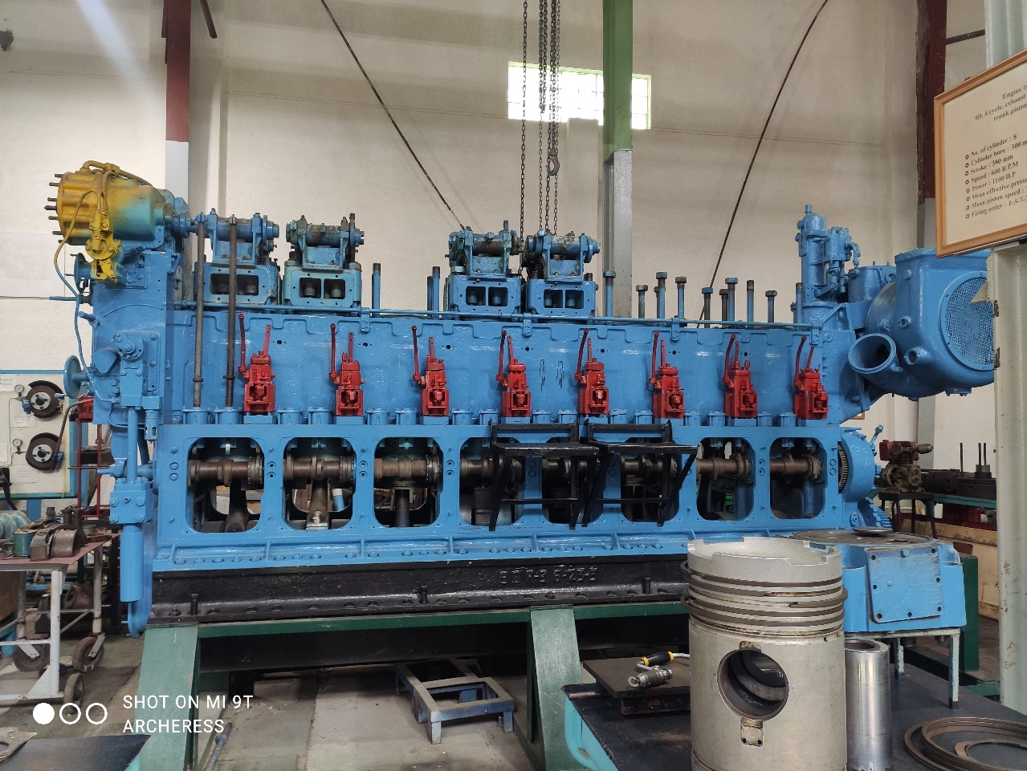The diesel engine is large in size and in this project, it is intended to overcome the size problem as to when it comes to practically studying the engine by giving students the feature of zooming in and out while examining the engine as a whole or its parts. It also has the explosion feature which enables students to see beyond one layer after the other. This makes it particularly easy to study the piston movements as the four strokes carry on along with the crank shaft movement.

Figure ‎3‑1: Selected Workshop Diesel Engine to Design

This project is based on virtualizing the Arab Academy’s Diesel Engine workshop. That is why it made sense to start by designing a replica of one of the diesel engines in the workshop. It was agreed to design the engine in Figure 1, for it is the engine students have their demonstrations on. Plus, its parts are all available to design and replicate with a convenient size.

## **3.2 DIESEL ENGINE DESIGN**

One of the core parts of this project is the mechanical design of the diesel engine. For this integral part, the choice of software was important as the software had to be powerful enough to make a rather large assembly like the diesel machine. Developed by the French software corporation Dassault Systems, SOLIDWORKS software was the best option to use to design the engine.

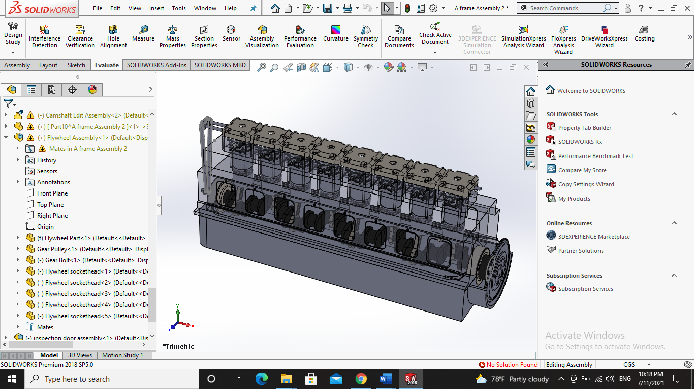In the design, 8 pistons are designed and attached to the crankshaft. The crankshaft is placed on the bedplate by the means of a tapered roller bearing. The A-frame has 8 inspection doors to showcase the piston rod and a part of the piston crown. the cylinder head consists of 4 valves; 2 for the intake and 2 for the exhaust. The valves are opened and closed according the 2 camshaft that are coupled to the movement of the crankshaft by the means of 2 pullies and a belt.

Figure ‎3‑2: The Project Designed Diesel Engine on SOLIDWORKS

## **3.3 Piston**

### **3.3.1 Function**

A piston is one of the greatest components that help the working of the combustion cycle. The engine part is enclosed in a cylinder block which use a piston ring to give no space for gas escape. The pistons help in the transformation of heat energy into mechanical work and vice versa. It moves upward and downward inside the cylinder in order to expand and contracts air-fuel mixture. For this reason, a piston is inevitable in an internal combustion engine.

According to [10], a piston is a mechanical device that moves upward to compress gas and downward due to explosion in a cylinder in order to transform heat energy into mechanical work. A piston follows a cyclical process for the continuation of the heat converting process. the process is achieved in three ways; providing heat to the gas inside the cylinder for the useful work, removing heat from the cylinder in order to decrease the pressure, so that the gas can easily be compressed, applying work to the piston when it’s in its initial state, ready to perform the cycle again.

Pistons play a vital role in the spark ignition gasoline engine and compression ignition diesel engine, which is the one used in our project. The major function of piston is to transfer the force output of a small gas explosion in the cylinder to a crankshaft. This provides rotational momentum to a flywheel. It moves forward so that gases can be compressed, and explosion can occur for the backward movement. The piston contains a pin called piston pin. A connecting rod attached to the piston’s bottom that allows the mechanical work to be transferred. Pistons help to carry the air-fuel mixture within the period of the combustion cycle. Pistons aid the control of oil flow in the cylinder walls using the oil control ring.

The piston has three rings: two compression rings, and one oil ring. In [11], it is explained that the compression rings provide sealing above the piston and prevent the gas leakage from the combustion side. The compression rings are located in the first grooves of the piston. The primary function of these rings is to seal the combustion gases and transfer heat from the piston to the piston walls. Oil is controlled by shearing the layer of the oil left by oil ring, thus providing the top compression rings enough lubrication. Moreover, it also provides help to the top compression ring in sealing and heat transfer.

The oil control rings control the amount of lubricating oil passing up or down the cylinder walls. These rings are also used to spread the oil evenly around the circumference of the liner. The oil is splashed onto the cylinder walls. These rings are also called scraper rings as they scrap the oil off the cylinder walls and send back to the crankcase. These rings do not allow the oil to pass from the space between the face of the ring and the cylinder.

### **3.3.2 Design**

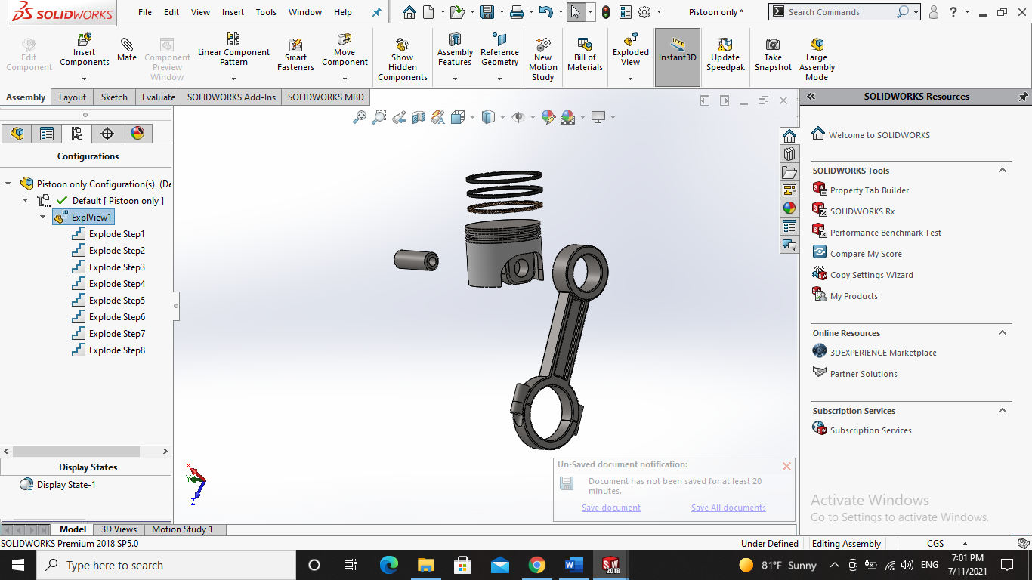As explained earlier, SOLIDWORKS is used in the three-dimensional design of the Diesel engine. The piston consists of a piston crown, a connecting rod, oil and compression rings as shown in Figure 1. The piston crown is 0.5 m in diameter similar to the workshop real diesel engine model.

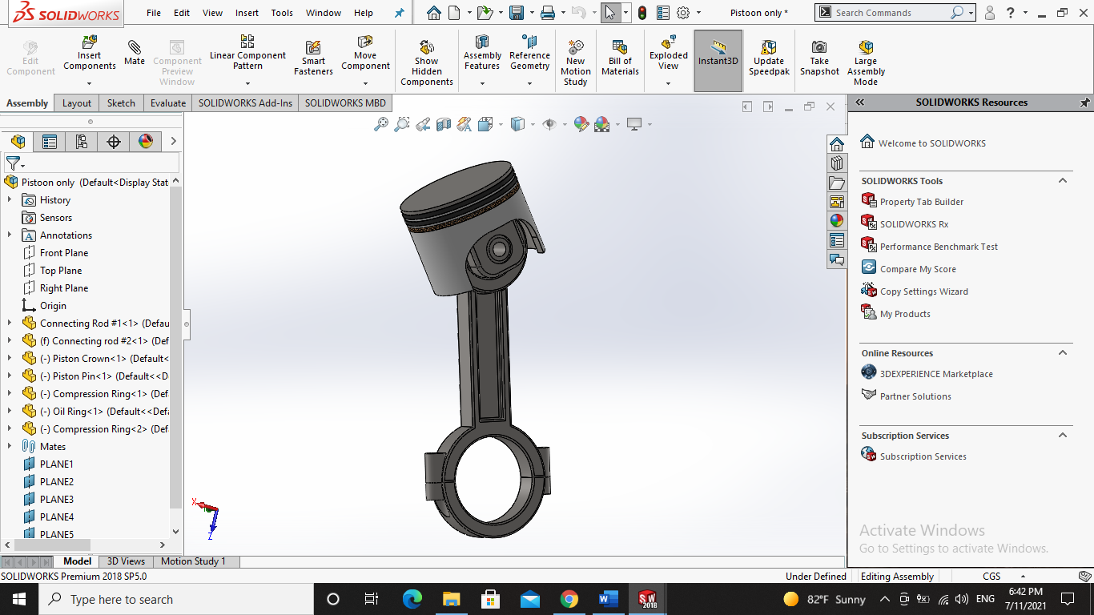

Figure ‎3‑3: Piston Design on SOLIDWORKS

## **3.4 Crankshaft**

### **3.4.1 Function**

The crankshaft is essentially the backbone of the diesel engine. The crankshaft is responsible for the proper operation of the engine and converting a linear motion to a rotational motion states [12]. The crankshaft converts reciprocating motion to rotational motion. It contains counterweights to smoothen the engine revolutions.

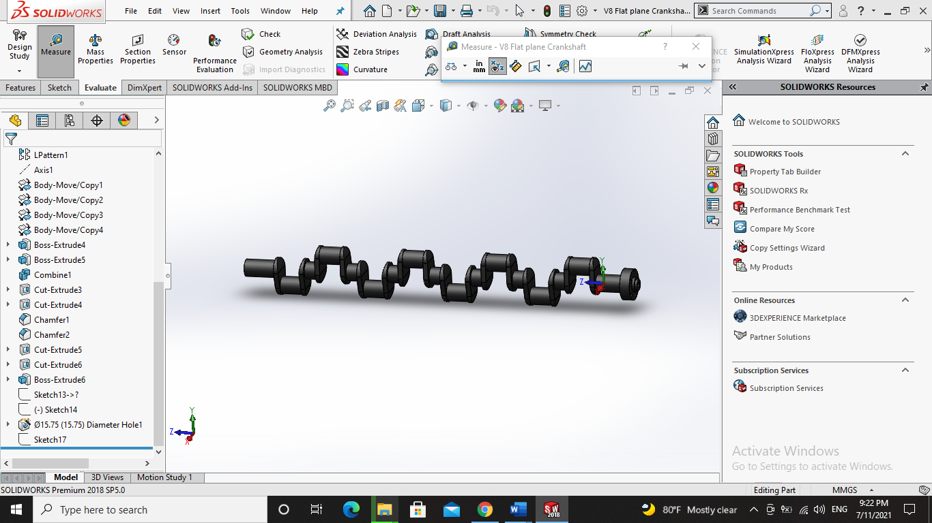

Figure ‎3‑4: Crankshaft Design on SOLIDWORKS

### **3.4.2 Design**

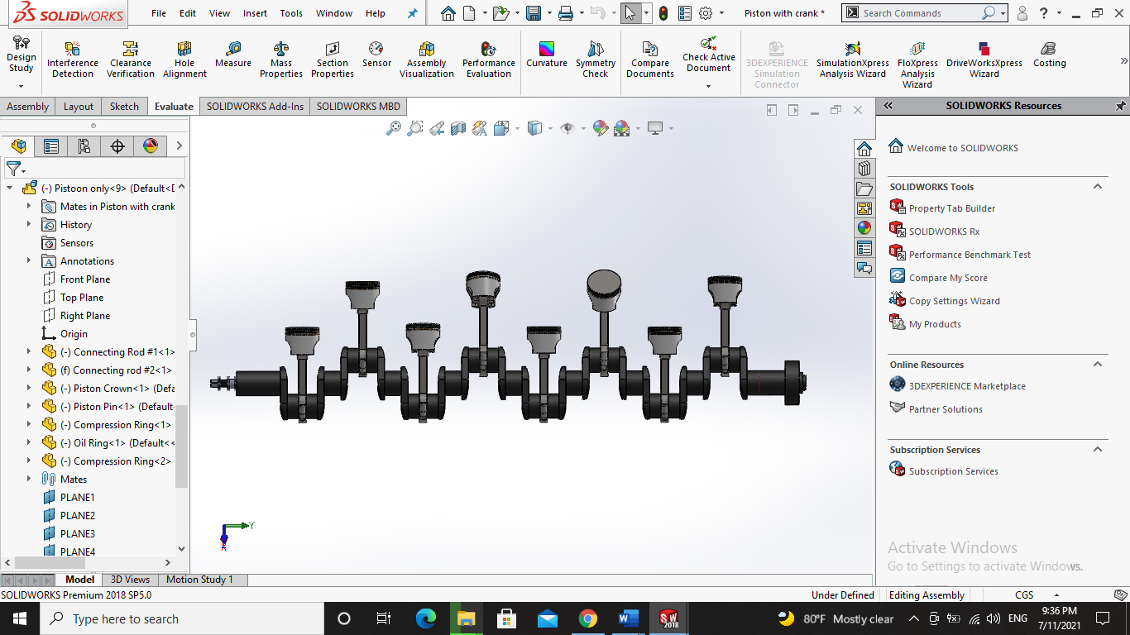The crankshaft is fitted into the engine block through its main journals. The connecting rods are fixed on the connecting rod journals of the crankshaft. Each connecting rod journal is 0.5 meter away from the other, which means that each piston is 0.5 meter from the next piston. Following [13], on opposite sides of the connecting rod journals the crankshaft has counterweights which compensates outer moments, minimizes internal moments and thus reduces vibration amplitudes and bearing stresses. At one end of the crankshaft the flywheel is connected and on the other end the valve timing gearing.

Figure ‎3‑5: Crankshaft with 8 pistons design

## **3.5 Bedplate**

A bedplate is the lowermost portion of a diesel engine, which supports the engine structure and is also one of the most loaded constructional parts of the engine. For large engines, the bedplate is fabricated in parts with flat bottom type construction having high surface finish. The bedplate is later arranged together during installation in large engines, whereas for smaller engines the bedplate is fully casted.

The function of the bedplate, as stated in [14], is to support the static load of stationary engine frame and blocks, support the dynamic load of the running gear, support the crankshaft and hold it in perfect alignment, distribute the static and dynamic load generated by running engine onto the ship structure, collect the crankcase lube oil and transfer it to the sump tank from where the lube oil pump can take suction, fasten the engine to the tank top transmitting propeller thrust to the hull structure, and contribute to the hull strength of the ship at engine room bottom structure. The bedplate dimensions are 5*2*0.7 m3.

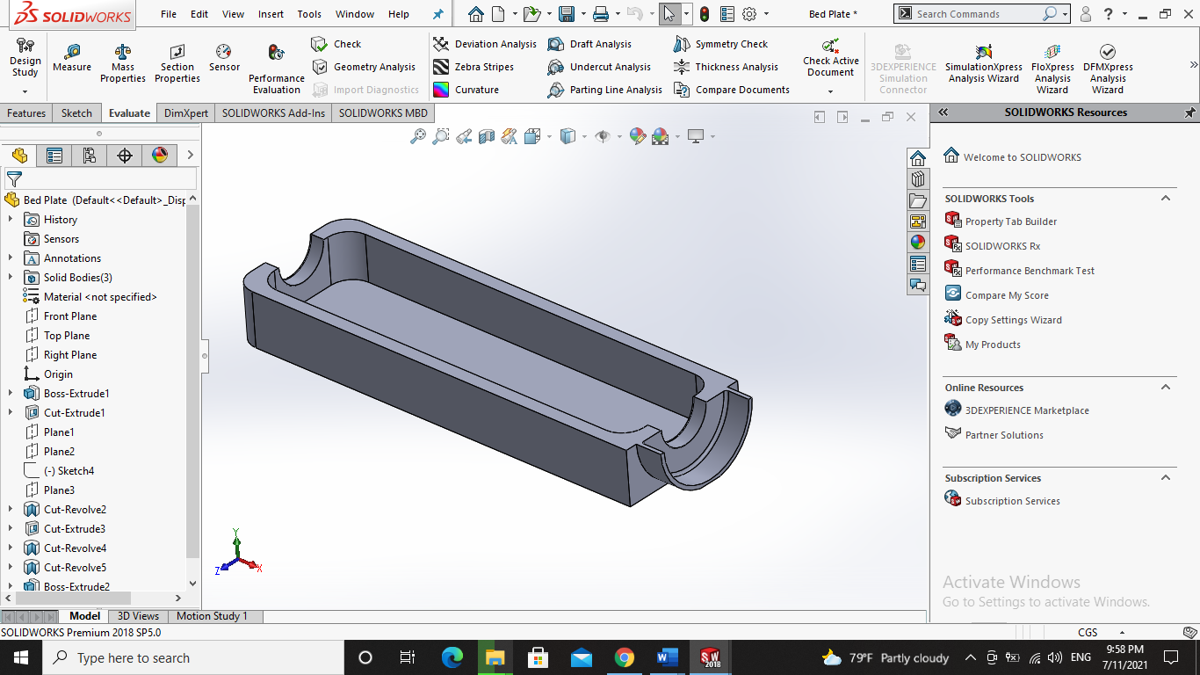

Figure ‎3‑6: Bedplate Design in SOLIDWORKS

The bedplate is connected to the A-frame, altogether forming the cylinder block. The crankshaft is installed on the bedplate by the use of bearings. Tapered roller bearing was selected to be used in the design. Following on [15], a tapered roller bearing is a unit that consists of both tapered raceways (inner and outer rings), and tapered rollers. The construction is intended for combination loads, such as dual acting axial and radial loads. The bearing axis is where the projected lines of the raceway combine at a common location to improve rolling, while reducing friction. The load capacity can be increased or decreased depending on the contact angle being increased or decreased. The higher the degree of angle, the greater the contact angle. They are commonly used in pairs for better radial load handling like this case with the crankshaft and the bedplate.

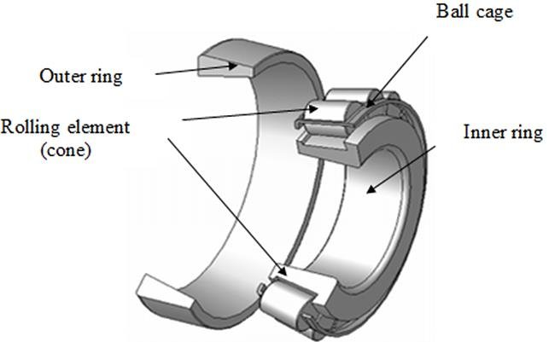

Figure ‎3‑7: Tapered Roller Bearing Illustration. image from Researchgate.com

## **3.6 Cylinder Block**

### **3.6.1 Function**

The main structural member of diesel engine is a cylinder block that usually extends upward from the center line of the main support for the crankshaft to the junction with the cylinder head, as stated in [16]. The block serves as the structural framework of the engine and carries the mounting pad by which the engine is supported in the chassis. Large, stationary power-plant engines and marine engines are built up from a foundation, or bedplate, and have upper and lower crankcases that are separate from the cylinder assemblies.

### **3.6.2 Design**

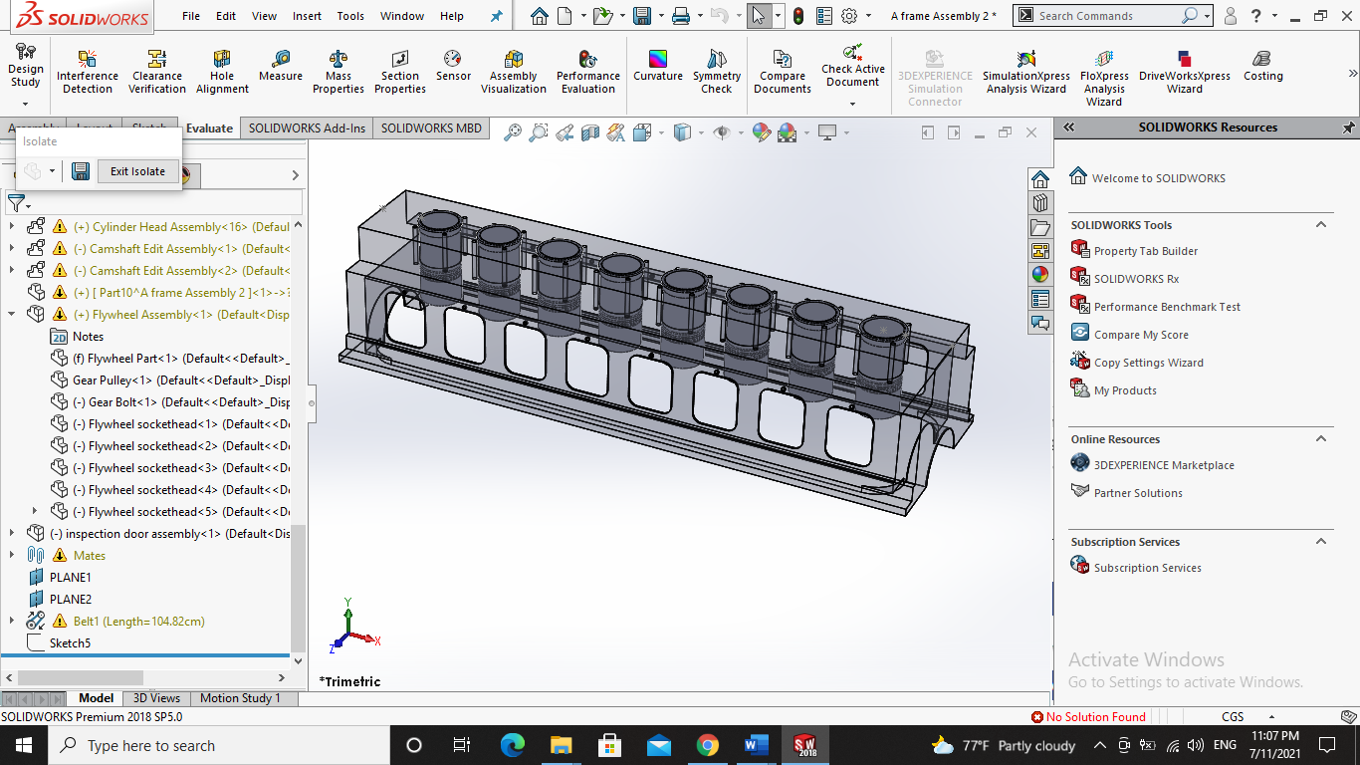The cylinder block of a diesel engine is a casting with appropriate machined surfaces and threaded holes for attaching the cylinder head, main bearings, oil pan, and other units. The crankcase is formed by the portion of the cylinder block below the cylinder bores and the stamped or cast metal oil pan that forms the lower enclosure of the engine and also serves as a lubricating oil reservoir, or sump.

Figure ‎3‑8: Cylinder Block Design in SOLIDWORKS

The cylinder block dimensions are 5*2*2.5 m3. The cylinder liners installed in the cylinder block are 60 cm long with an inner diameter of 50 cm.

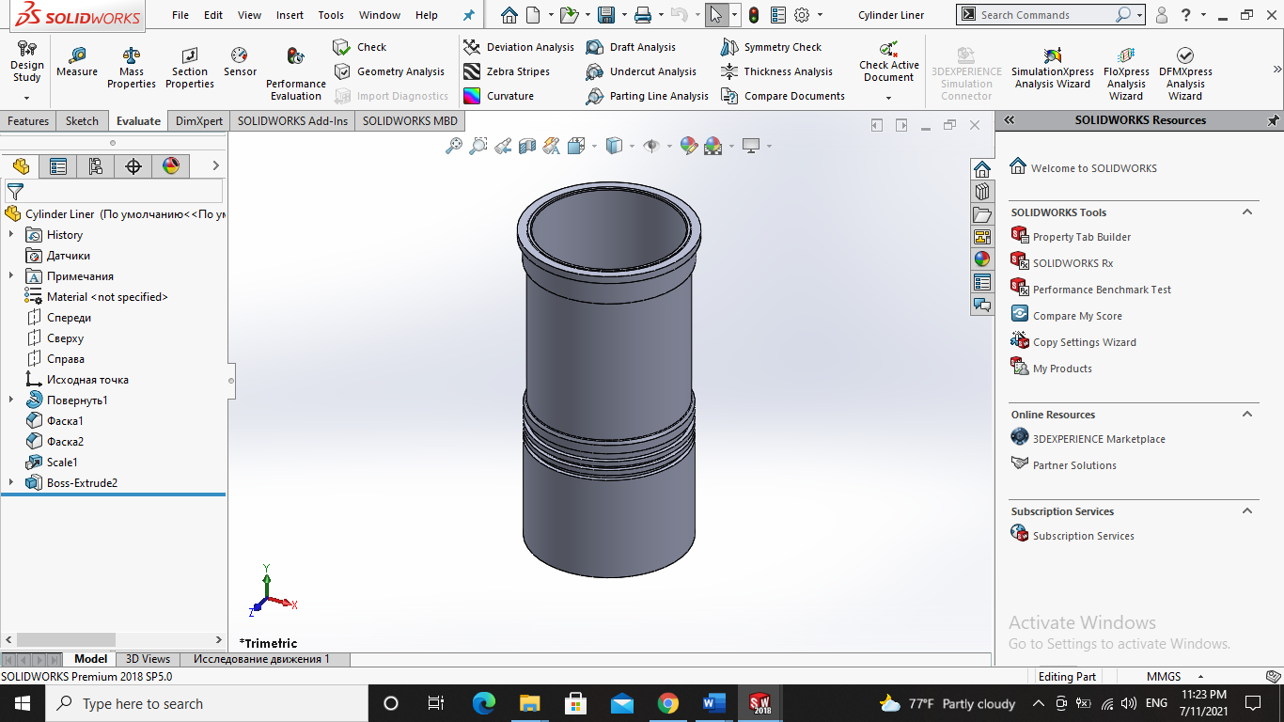

Figure ‎3‑9: Cylinder Liner Design in SOLIDWORKS

## **3.7 Cylinder Head**

A cylinder head is the cast metal part that covers the top part of a cylinder. According to [14], the cylinder head mounts on the cylinder block or engine housing. Together with the piston and cylinder liner, it forms a part of the combustion chamber. Underneath the cylinder head lies the cylinder head gasket. The gasket seals the head to the cylinder block, preventing leaks.

The cylinder head plays an important role in the general operation of a motor vehicle. It is a complex structure consisting of many passageways. Each of these ports has a purpose to serve, and their collective roles define the importance of this engine part. Among the main cylinder head function in an engine are: it provides the mounting structure for various components such as the inlet and outlet exhaust valves and ducts, fuel injectors, and the camshaft, it contains the passages for coolant, oil, and combustion gases, it dissipates the heat produced by the engine, it acts as the combustion chamber seal and the engine’s mechanical control powerhouse, and it compresses the air increasing its pressure against the movement of the piston in the cylinder liner. A cylinder head contains intake air, exhaust, and oil passageways.

## **Graphical user interface Description automatically generatedA screenshot of a computer Description automatically generated with medium confidence3.8 Valves**

Figure ‎3‑10: Cylinder Head Exploded view and assembled view in SOLIDWORKS

According to [16], The valve-in-head engine has pushrods that extend upward from the cam followers to rocker arms mounted on the cylinder head that contact the valve stems and transmit the motion produced by the cam profile to the valves. Clearance (usually termed tappet clearance) must be maintained between the ends of the valve stems and the lifter mechanism to assure proper closing of the valves when the engine temperature changes. This is done by providing pushrod length adjustment or by the use of hydraulic lifters.

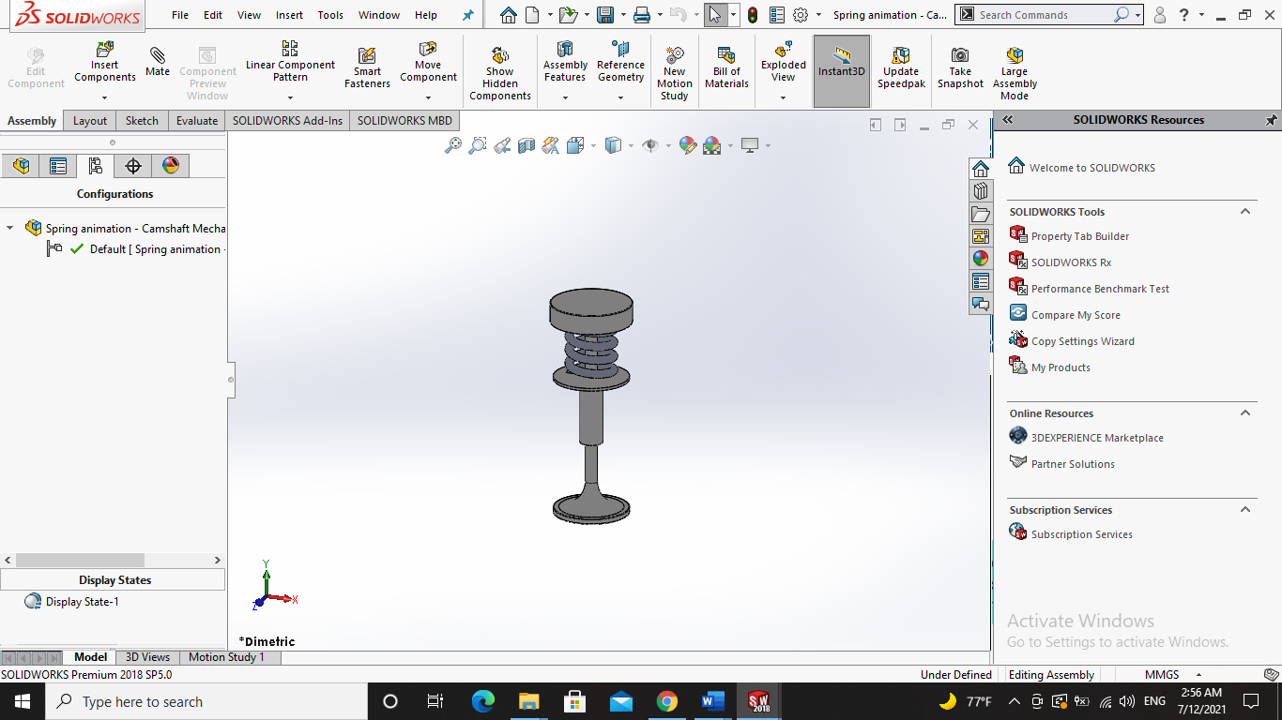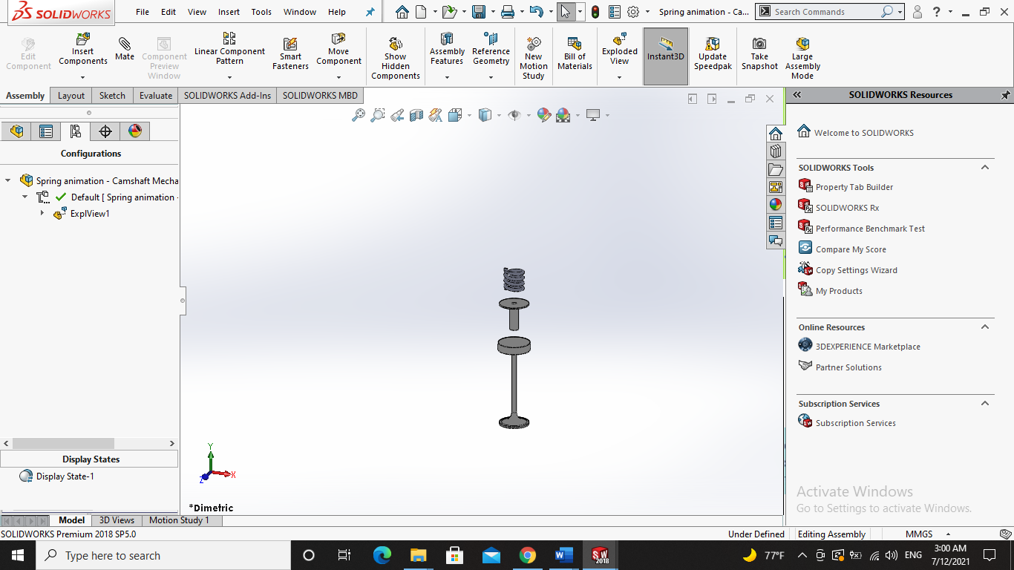

Figure ‎3‑11: Spring valve assembled and exploded view in SOLIDWORKS

The hydraulic lifter comprises a cam follower that is moved up and down by contact with the cam profile, and an inner bore into which the valve lifter is closely fitted and retained by a spring clip. The valve lifter, in turn, is a cup closed at the top by a freely moving cylindrical plug that has a socket at the top to fit the lower end of the pushrod. This plug is pushed upward by a light spring that is merely capable of taking up the clearance between the valve stem and the rocker arm. A small hole is drilled in the bottom of the valve-lifter cup to admit lubricating oil that enters the cam follower from the engine lubricating system through a passage in the cylinder block. A small steel ball serves as a check valve to admit the oil into the valve-lifter cup but prevent its escape.

The intake valve must be open while the piston is descending on the intake stroke of the piston, and the exhaust valve must be open while the piston is rising on the exhaust stroke. It would seem, therefore, that the opening and closing of the two valves would occur at the appropriate top and bottom dead-center points of the crankshaft. The time required for the valves to open and close, however, and the effects of high speed on the starting and stopping of the flow of the gases require that for optimum performance the opening events occur before the crankshaft dead-center positions and that the closing events be delayed until after dead center.

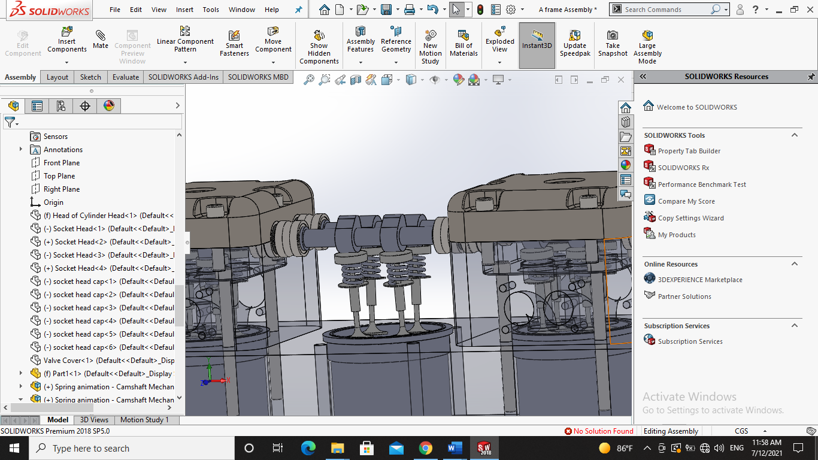

Figure ‎3‑12: Valve Mechanism with Camshaft in a Cylinder Head in SOLIDWORKS

All four valve events—inlet opening, inlet closing, exhaust opening, and exhaust closing—are accordingly displaced appreciably from the top and bottom dead centers. Opening events are earlier and closing events are later to permit ramps to be incorporated in the cam profiles to allow gradual initial opening and final closing to avoid slamming of the valves. Ramps are provided to start the lift gradually and to slow down the valve before it contacts its seat. Early opening and late closure are also for the purpose of using the inertia or persistence of flow of the gases to assist in filling and emptying the cylinder.

## **3.9 Camshaft**

A camshaft is a rod which rotates and slides against a piece of machinery in order to turn rotational motion into linear motion. This change of motion is accomplished by the camshaft moving further and closer from the axis of rotation as the camshaft is pushed by the machinery. These moving pieces of the shaft are the cams.

A camshaft on an internal combustion heat engine is a device that controls both the input of fuel and the expulsion of exhaust fumes, states [17]. It consists of several radial cams, each displacing intake or exhaust valves. This camshaft is connected to the crankshaft via a belt and gears. This ensures consistent timing of the valves in relation to the motion of the pistons.

The function of a camshaft is dependent on how a valve works and the function of the cam itself. A valve on a cylinder head consists of two basic parts, a stem and a head (see Figure 11). The head plugs the nozzle that allows fuel intake or exhaust flow and requires linear motion. A cam, in its simplest definition, is a mechanical link that converts rotational motion into linear motion, or vice versa. The cams on a camshaft achieve this displacement by the rotation of a radial pattern, and a follower which moves perpendicular to the rotational axis. The cam pattern on a camshaft is non-circular with a single lobe. The follower matches the displacement of the cam as it rotates. This displacement is then translated to the stem of the valve, allowing head to rise as the lobes of the cam pass through the follower.

Since that diesel engine has 8 cylinders and hence 8 pistons, a single cam is insufficient for all of these pistons. An entire rod covered with cams must be used. This is the camshaft seen in Figure 3-13. Note that the precise placement of the cams along the shaft allow for precise timing of the relative valves opening and closing.

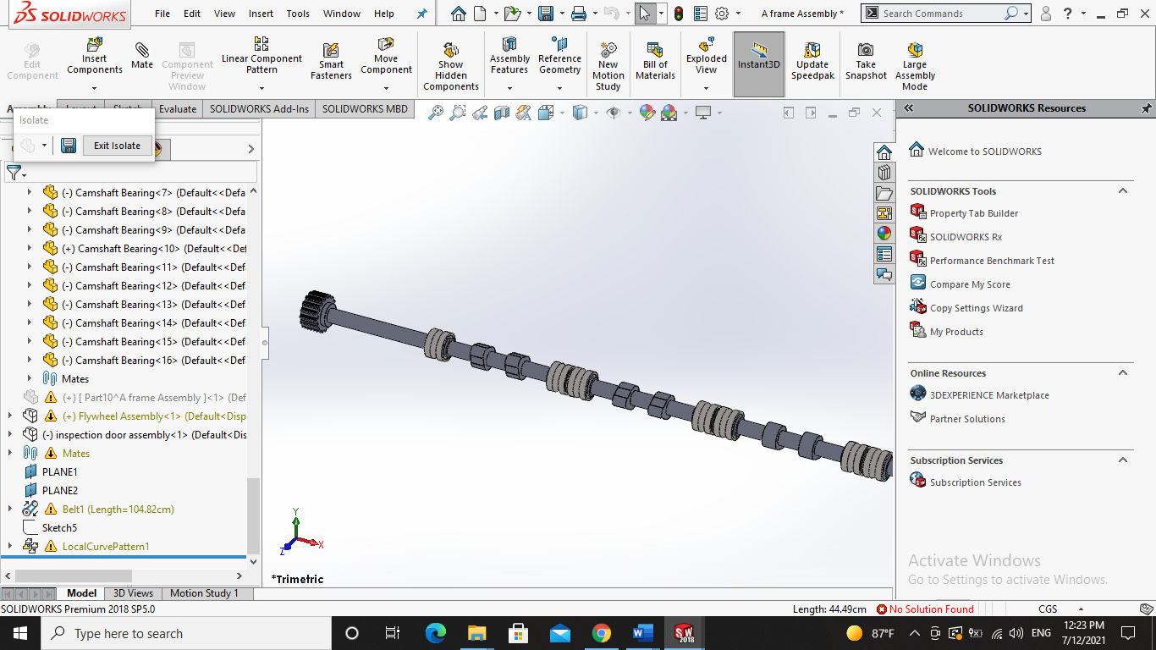

Figure ‎3‑13: Part of the Camshaft Design with Cam Bearings in SOLIDWORKS

## **3.10 Timing Belt**

Accrording to [18], timing belt, timing chain, or cambelt is a part of an internal combustion engine that synchronizes the rotation of the crankshaft and the camshafts so that the engine's valves open and close at the proper times during each cylinder's intake and exhaust strokes. In an interference engine, the timing belt or chain is also critical to preventing the piston from striking the valves. The used timing belt in this design is a toothed belt—a drive belt with teeth on the inside surface.

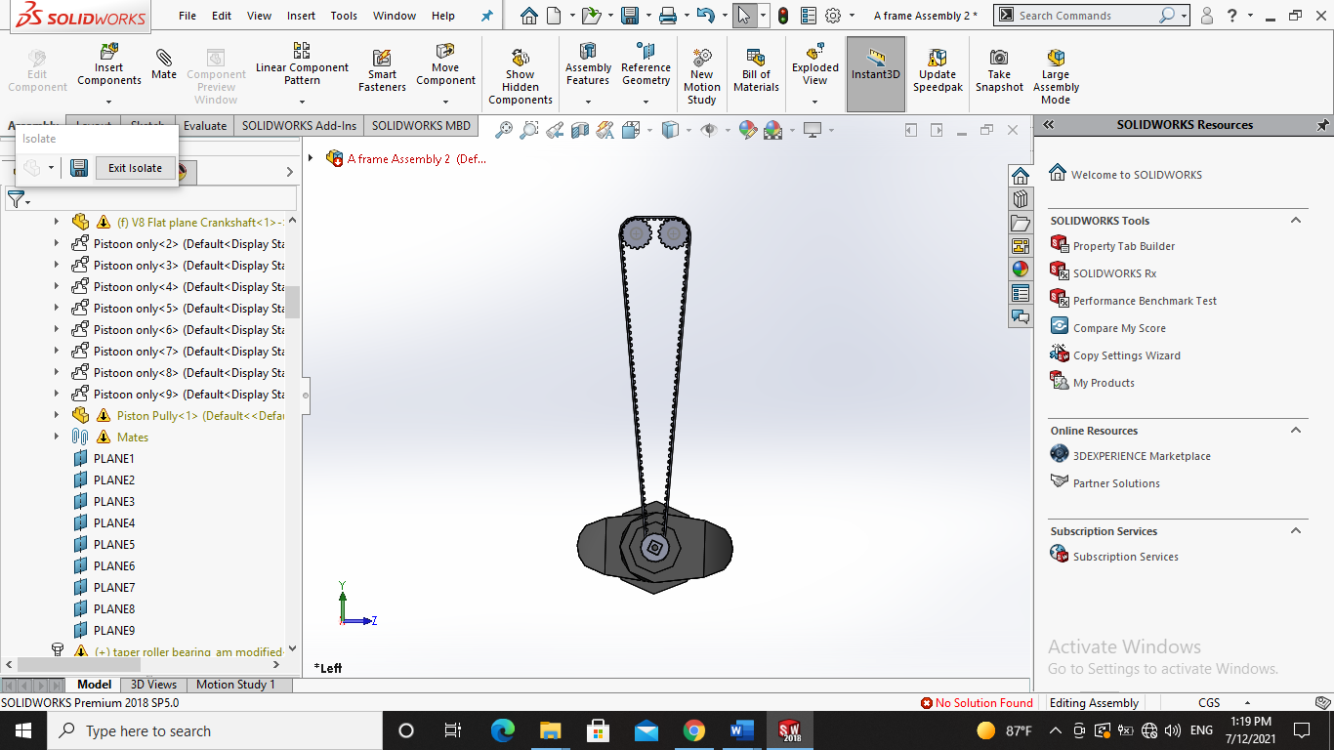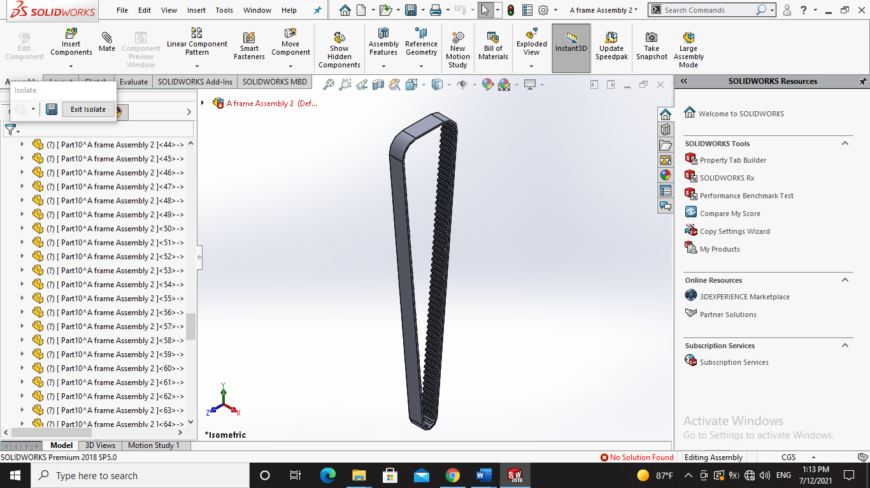

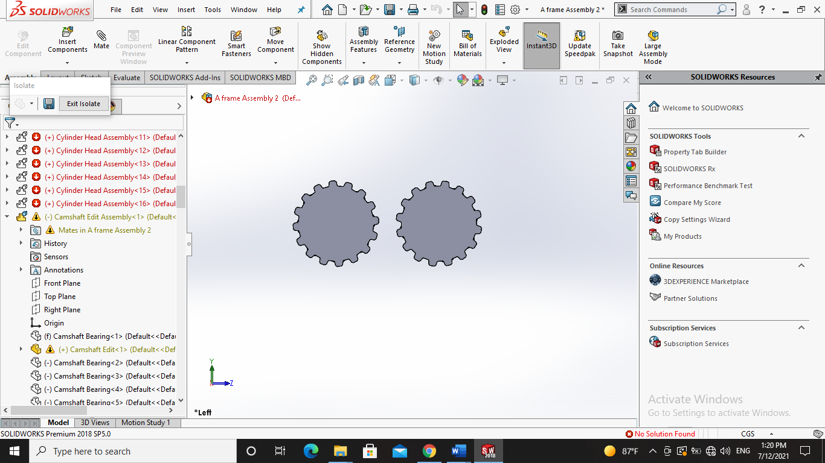

Figure ‎3‑14: a) Timing Belt, b) Cam Gears, c) Timing Belt with Gears Assembly

Timing belts are used to synchronize crankshaft and camshaft rotation; using a chain that enables the placement of the camshafts far from the crankshaft, and in engines, with multiple camshafts a timing belt or chain also enables the camshafts to be placed further from each other. In the diesel engine, the application of a timing belt or chain connects the crankshaft to the camshafts, which in turn control the opening and closing of the engine's valves. A four-stroke engine requires that the valves open and close once every other revolution of the crankshaft. The timing belt does this. It has teeth to synchronize the camshafts with the crankshaft.

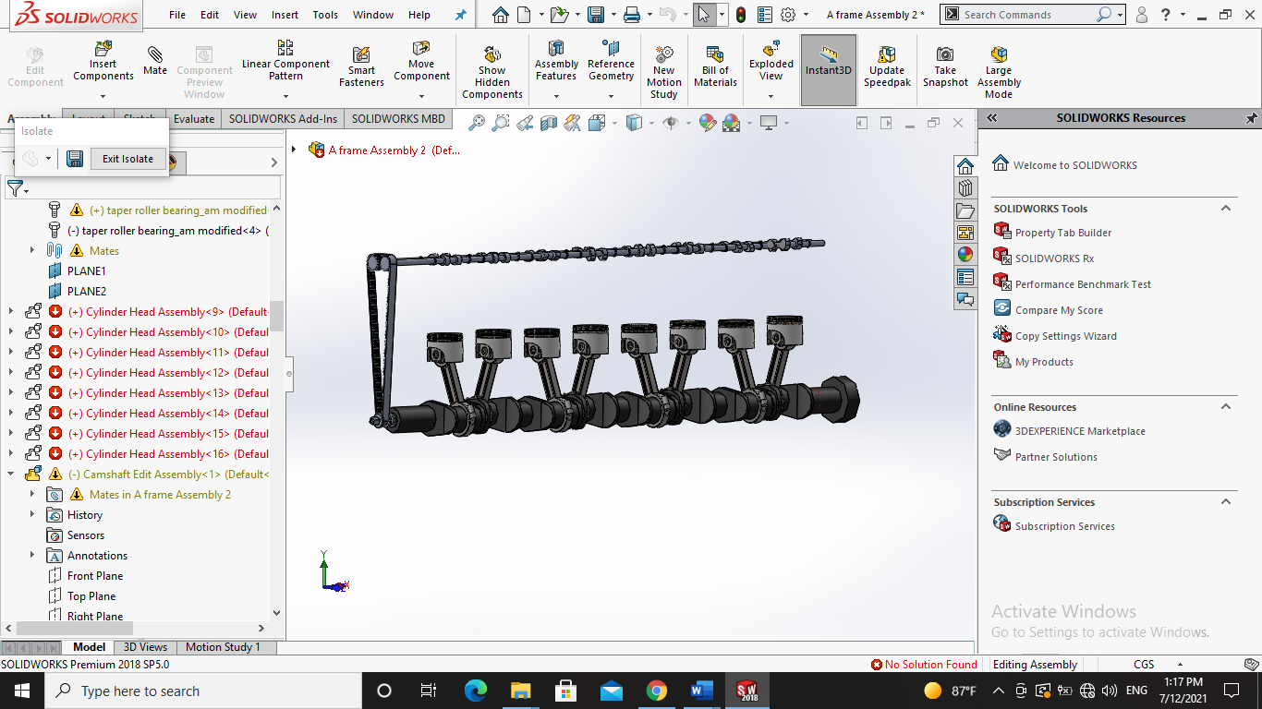

Figure ‎3‑15: Timing Belt Connecting the Crankshaft with the Camshaft

## **3.11 Flywheel**

The flywheel is mounted on the one side of a crankshaft of the transmission line, to reduce the imbalance of the rotational force on the crankshaft. In the case of the four-stroke engine, in each cylinder, one power stroke is generated per two revolutions of the crankshaft, states [18]. The flywheel stores this energy as kinetic energy and provides the same in the other strokes (compression, intake, and exhaust) for a continuous engine run. Therefore, in the absence of a flywheel, the rotation of the crankshaft has become pulsating; and when the interval of the power stroke becomes long as in the idling state, the engine gets stopped. The flywheel assembled on a crankshaft must have been dynamically balanced. Dynamically unbalanced assembly causes vibration of the crankshaft as well as a large load on the crankshaft and bearing.

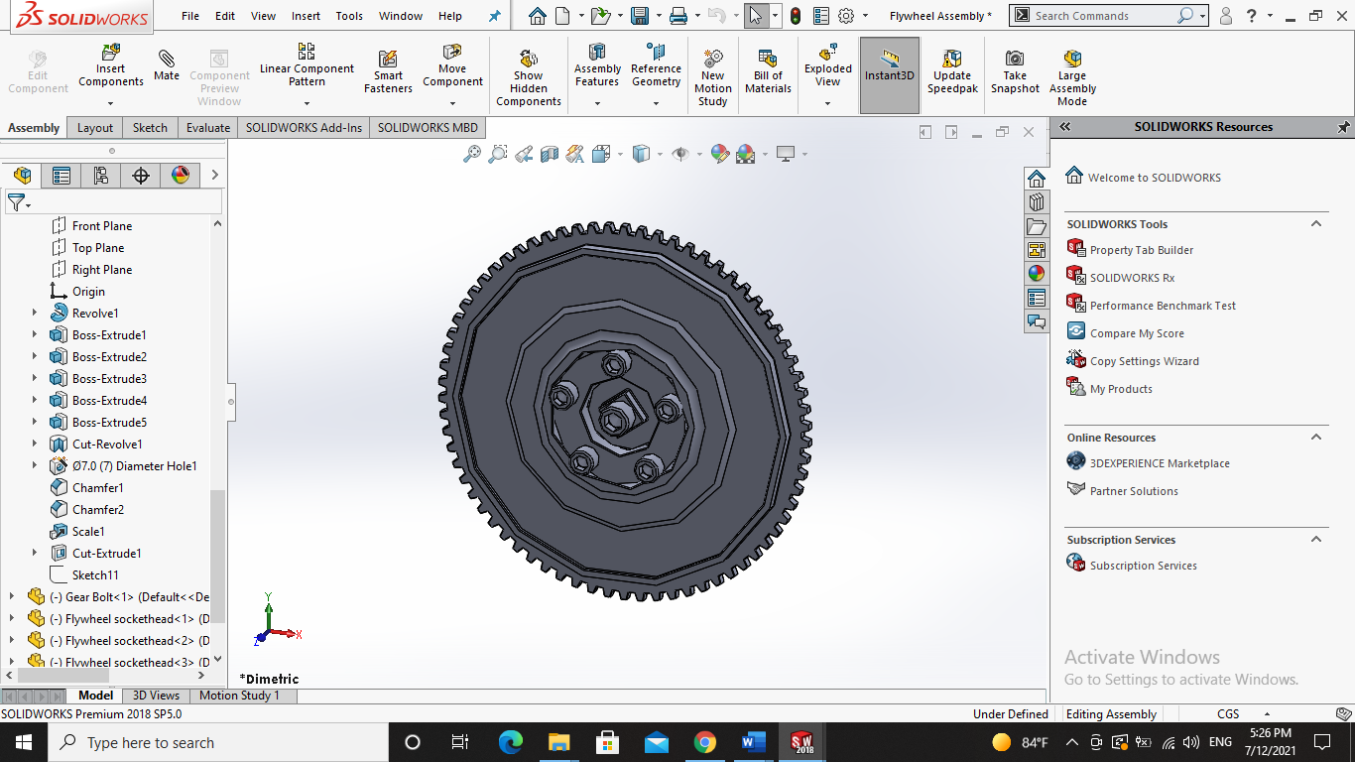

Figure ‎3‑16: Flywheel Design in SOLIDWORKS

Chapter Four

# **Virtual Reality**

## **4.1 Introduction**

After building the 3D model, it is time to bring our model into a virtual world of our creation with maintaining the essential educational environment of the laboratory and adding the features that cannot be applied in reality to come up with the maximum output. In order to do that we have to understand more about virtual reality from different perspectives. Our focus during project one was to fully understand the different types of VR technology and VR components like hardware and software. Also, deciding what hardware and software to be used in our project.

### **4.1.1 Types of Virtual reality**

* **Non-immersive Virtual Reality**

Non-immersive virtual reality that also called desktop VR or window on world (WoW) systems is a type of virtual reality in which the user can only control a character or activity without immersion or environment interference. In this type of VR, the desktop system consists of a standard screen to display the 3D world at a satisfactory level of graphics quality, user comfort, and convenience at a low cost. Examples of Non-immersive VR systems are PlayStation, Xbox, and Computer video games.

* **Fully Immersive Virtual Reality**

On contrary to non-immersive virtual reality, a fully immersive virtual technology ensures that the user has a realistic experience within the virtual world in order to make him feels like he is in a physical presence in the virtual world and everything around him is happening for real. This is an expensive form of virtual reality that involves headsets, gloves, and body connectors with sense detectors. These are connected to a powerful microcomputer. Movements, reactions, and even a blink of an eye are detected and projected within the virtual world. However, a fully immersive virtual reality is costly and not so widely created yet.

* **Semi-Immersive Virtual Reality**

A semi-immersive virtual reality is a mixture of non-immersive and fully immersive virtual reality. This can be in the form of a 3D space or virtual environment where the user can move about on his own either through a computer screen or a VR headset. So, all activities within the virtual world are concentrated on the user. However, he will have limited physical movements other than his visual experience. On a computer, the user can use the mouse to move about the virtual space, and on mobile devices, he can touch and swipe to move about the place. Most semi-immersive virtual environments support Gyroscope, which means the virtual space will be fixed on a phone-based vertical axis, and the user has to move his phone about in different directions to view the virtual environment in those directions. Swiping will not work. The ones that are connected to VR headsets are more interactive since they are also a form of Gyroscope, but without using hands. When a user wears a VR box/headset, he will only be able to see the virtual environment and not the real world even with the corner of his eye. Thus, creating a realistic experience. Semi-immersive virtual reality is the most cost-effective and commonly used among all forms of virtual reality after non-immersive VR. A virtual tour is the most popular semi-immersive virtual reality that most businesses are embracing today. They can be both device-based or web-based. Overall, they provide an interactive virtual experience. [19]

* **Augmented Reality**

Augmented Reality is when a certain entity or device seems to be present in reality but it is actually not. Rather than putting the user into a virtual world, a virtual entity is placed in the real world through any device. For instance, through a mobile screen, the user can view his room, and probably place a cartoon character in the corner. He will be able to see the character through his mobile screen and not in reality. It is mostly used by businesses such as furniture suppliers or decorators. For example, a person willing to buy a table will be able to place the table in his room through his phone display. This will let him understand if this table is suitable and looks good in his room, or he has to choose another design. Augmented reality often is argued to be a unique form of technology rather than VR. But its ability to place entities virtually often puts it within the VR category.[20]

* **Collaborative VR**

This is a form of a virtual world where different people from various locations can come into contact within a virtual environment, usually in the form of 3D or projected characters. For example, there is a video game called PUBG (Players Unknown Battle-Ground), where tons of players come to existence as individual virtual characters which they can control. Here they can interact with each other through microphones, headsets, and chatting. Additionally, people are recently getting used to virtual meeting rooms to conduct business meetings remotely, or for conducting virtual debate competitions. The main goal of this form of VR is the collaboration between people in the virtual world. [19]

### **4.1.2 VR Components**

* **VR Input Devices**

The input devices are the means by which the user interacts with the virtual world. They send signals to the system about the action of the user, so as to provide appropriate reactions back to the user through the output devices in real-time. They can be classified into two categories which are hand input devices and non-hand input devices.

Hand input devices are the devices in which User only to do specific gestures with his hand in order to transfer these gestures into commands in the real world. There are different types of hand input devices. Firstly, the world-grounded input device in which the device is usually grounded or wired into a system. Secondly, there are the non-tracked handheld controllers. Thirdly, the tracked handheld input devices which are the most common used input devices in the VR systems. Also, there are hand worn input devices which come in different forms such as gloves, rings or armbands. Last but not least, some systems provides tracking the bare hand motion to use it as an input device.

On the other hand, there are input devices that are non-hand input. In this set of devices different hardware are used to perform head and eye tracking, body tracking using either cameras or full body sensors suit. Additionally, there are different types of these devices such as using voice as an input device.[21]

* **VR output devices**

The output devices get feedback from the VR engine and pass it on to the users through the corresponding output devices to stimulate the senses. The possible classifications of output devices based on the senses are: graphics (visual), audio (aural), haptic (contact or force), smell and taste. Of these, the first 3 are frequently used in VR systems, while smell and taste are still uncommon. Two possible common options for the graphics are the stereo display monitor, and the head-mounted display (HMD) which provides a higher level of immersion. In the HMD, the two independent views produced are interpreted by the brain to provide a 3D view of the virtual world. Audio or sound is an important channel in VR. Its importance is only surpassed by that of visual. 3D sound can be used in producing different sounds from different location to make the VR application more realistic. Haptic is used to allow the user feel virtual objects. This can be achieved through electronic signals or mechanical devices. [21]

* **VR Engine**

Despite it is immersed in the output device, VR engine is the most important part in the system. In VR systems, the VR engine or computer system has to be selected according to the requirement of the application. Graphic display and image generation are some of the most important factors and time-consuming task in a VR system. The choice of the VR engine depends on the application field, user, I/O devices, level of immersion and the graphic output required, since it is responsible for calculating and generating graphical models, object rendering, lighting, mapping, texturing, simulation and display in real-time. The computer also handles the interaction with users and serves as an interface with the I/O devices. A major factor to consider when selecting the VR engine is the processing power of the computer, and the computer processing power is the number of senses (graphical, sound, haptic, etc) that can be rendered in a particular time frame as pointed. The VR engine is required to recalculate the virtual environment approximately every 33ms and produce real time simulation of more than 24fps, furthermore, the associated graphic engine should be capable of producing stereoscopic vision.[20]

* **Software**

Virtual reality system software is a collection of tools and software for designing, developing and maintaining virtual environments and the database where the information is stored. There are different types of VR software as follow:

* **VR visualization:** This type of software allows users to experience aggregated data in a virtual environment. These tools enable users to see analytics in a way for them to fully understand what the data are communicating.
* **VR content management systems:** Businesses can use these tools to collect, store, and analyze all VR content in a centralized location.
* **VR SDK:** Virtual reality software development kits (SDK) provide the necessary base to design, build, and test VR experiences. VR SDKs act as the building blocks to create basically any VR experience.
* **VR game engine:** This software provides developers with the essential for creating a VR video game experience.
* **VR social platforms:** Users can collaborate in VR from remote locations using these tools.
* **VR training simulator:** These tools can be used in almost any industry to train employees in a completely immersive environment.[22]

### **4.1.3 Project specifications**

* **VR type used:**

Since our project is aiming to provide the most possible immersive learning experience for students with maintaining a reasonable financial budget for the educational institutions, we have decided to use the semi-immersive VR type integrated with human activity recognition as an input system. Semi-immersive VR are commonly used and applicable at a low cost which makes it the perfect candidate for our project.

* **Hardware used:**
* VR output device

We have chosen Oculus quest VR headset to be our output device. Oculus Quest is Facebook’s first standalone headset that offers six degrees of freedom (6 DoF) tracking. This means that the headset has the same full tracking capabilities typically reserved for high-end PC driven VR headsets. Oculus quest have many specifications that made us choose it as follow:

|  |  |
| --- | --- |
| Display Panel | OLED |
| Display resolution | 1440 x 1600 per eye |
| Refresh rate | 72 Hz |
| Processor | Qualcomm Snapdragon 835 |
| RAM | 4 GB |
| Battery | Lithium-ion battery with 2-3 hours playtime |
| Degree of freedom | 6 degrees of freedom head and hand tracking |
| Weight | 571g |
| Price | Two models are available: a 64gb model for $399 and 128gb for $499 |

Table ‎4‑1: Oculus quest specifications

* **VR software used**

Since the first step in our project is the proof of concept, we have been searching for the best software that would provide us with the essentials for creating a VR video game experience. Thus, we have chosen Unity game engine.

Unity is a software solution for real-time game and content developers which is powered by tools and services to help create interactive content. With its all-in-one editor, the app is compatible with Windows, Mac, and Linux. It supports both 2D, 3D and VR content with a number of custom tools available and immersion of design, programming using C# and simulation into one software.

## **4.2 Unity Interface**

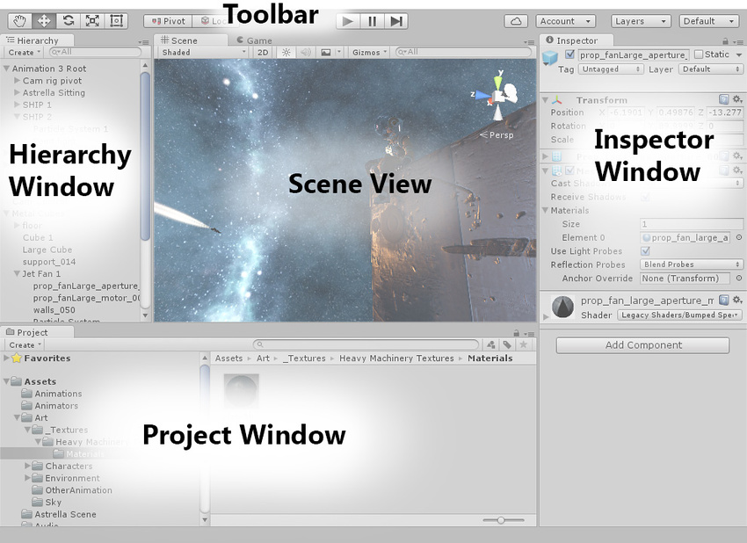

Figure ‎4‑1: Unity interface

The Unity interface is made up of five main windows. The Scene view, The Project window, The Hierarchy window, The Inspector window and the Game view. At the top of the Unity interface is the toolbar. The Scene view is where the environment is visually built. The Scene view allows looking at and directly interacting with the GameObjects in the Scene. The Project window displays all of the assets available to build the game with. Assets are files that are saved on the hard drives. The Project window gives an easy access to these files, including Scripts, Textures, 3D Models, Audio Clips, Scenes and other assets. The Hierarchy window shows a list of all of the GameObjects currently used in the Scene. GameObjects in this list can be moved and rearranged to suit our preference. GameObjects in the Hierarchy can be grouped together to make GameObject families. The GameObject at the top of each Hierarchy group is the Parent. GameObjects grouped inside of the Parent GameObject are its children. The Inspector is a context-sensitive window. The Inspector shows all of the properties of any GameObject or asset that we have selected. When we select an asset from the Project window, or a GameObject, from either our Scene view, or Hierarchy window, The Inspector displays the details and properties of our selected item. The Game view allows preview of the game in the Editor. By using the Play controls in the toolbar, play test to the game can be done at any time. The Play controls allow to play, pause, or step frame by frame through our game. The toolbar contains the Transform tools and Gizmo toggles, the Play controls, controls for Unity Services and accounts, and the Layer, and Layout menus. The Transform tools allow navigation and manipulation of the GameObjects in the Scene. The adjacent Transform Gizmo toggles allow to switch between center or pivot point rotation, and Local or Global World Space navigation. To the right of the Play controls there are the Unity Collab, Cloud Service, and Account Service controls. These tools allow to upload and download updates to shared projects, and manage our Cloud Service settings. The Account dropdown menu provides a shortcut to accessing our account settings on the Unity ID web page, and allows to sign in or out of our account within the Editor. The Layers dropdown menu allows to quickly show and hide layers of content in the game. The Layout dropdown menu allows to switch between different saved layouts for the Unity interface. The windows in the Unity Editor can be easily adjusted and rearranged to suit our needs. We can create a new layout by moving the windows into the new positions, and we can store any new layout we create as a custom layout. With the Layout dropdown menu, we can quickly return to these saved layouts in the future. So, with only five main windows and a simple toolbar, it is easy it is to navigate the Unity Editor interface. [23]

## **4.3 Scene**

Scenes are where work with content is done in Unity. They are assets that contain all or part of a game or application. For example, a simple game in a single scene can be built, while for a more complex game, one scene per level can be used, each with its own environments, characters, obstacles, decorations, and UI. When creating a new project and opening it for the first time, Unity opens a sample scene that contains only a Camera and a Light. [23]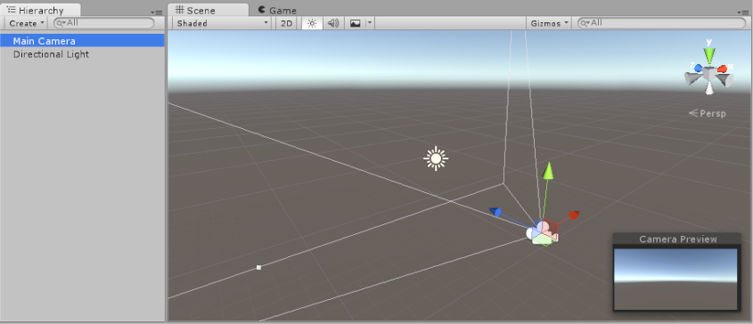

Figure ‎4‑2: The default Unity sample scene, which contains a Main Camera and a directional Light

Unity uses scene templates to create new scenes. Scene templates are assets that are stored in a project. They are similar to scenes, but are designed to be copied rather than used directly.

The New Scene dialog opens when creating a new scene from the File menu: (File > New Scene) or the Ctrl/Cmd + n shortcut. Uses to create new scenes from specific scene templates in the project, and get information about existing templates. When Creating a new scene, The new scene window opens that contains Search field to find available scene templates by name, Templates which is a list of all available templates in the project, Template details that displays information about the currently selected template and Command bar which provides commands and options for creating a new scene from the selected template. [25]

## **4.4 GameObject**

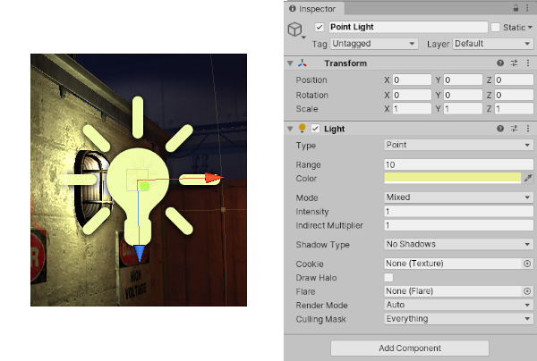The GameObject is the most important concept in the Unity Editor. Every object in the game is a GameObject, from characters and collectible items to lights, cameras and special effects. However, a GameObject can’t do anything on its own; it needs to be given properties before it can become a character, an environment, or a special effect. GameObjects are the fundamental objects in Unity that represent characters, props and scenery. They do not accomplish much in themselves but they act as containers for Components, which implement the functionality. To give a GameObject the properties it needs to become a light, or a tree, or a camera, Components need to be added. Depending on what kind of object to create, different combinations of components are added to a GameObject. Unity has lots of different built-in component types, and new Components can be added through scripting. For example, a Light object is created by attaching a [Light](https://docs.unity3d.com/Manual/class-Light.html) component to a GameObject. Additionally, a GameObject always has a [Transform](https://docs.unity3d.com/2020.3/Documentation/Manual/class-Transform.html) component attached (to represent position and orientation) and it is not possible to remove this. The other components that give the object its functionality can be added from the editor’s Component menu or from a script. There are also many useful pre-constructed objects (primitive shapes, Cameras, etc) available on the GameObject > 3D Object menu. [26]

Figure ‎4‑3: A simple Light GameObject with several Components

## **4.5 Transforms, Parenting and Scale**

The Transform is used to store a GameObject’s position, rotation, scale and parenting state and is thus very important. A GameObject will always have a Transform component attached. It is not possible to remove a Transform or to create a GameObject without one. The Transform component determines the Position, Rotation, and Scale of each object in the scene. Every GameObject has a Transform.

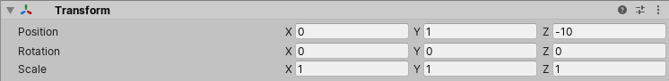

Figure ‎4‑4: Transform

Properties of transform are:

|  |  |
| --- | --- |
| Property: | Function: |
| Position | Position of the Transform in X, Y, and Z coordinates. |
| Rotation | Rotation of the Transform around the X, Y, and Z axes, measured in degrees. |
| Scale | Scale of the Transform along X, Y, and Z axes. Value “1” is the original size (size at which the object was imported). |

Table ‎4‑2: Properties of transform

The position, rotation and scale values of a Transform are measured relative to the Transform’s parent. If the Transform has no parent, the properties are measured in world space. Transforms are manipulated in 3D space in the X, Y, and Z axes or in 2D space in just X and Y. In Unity, these axes are represented by the colors red, green, and blue respectively.

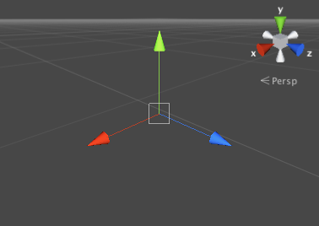

Figure ‎4‑5: A transform showing the color-coding of the axes

A Transform can be edited in the Scene View or by changing its properties in the Inspector. In the scene, Transforms are modified using the Move, Rotate and Scale tools. These tools are located in the upper left-hand corner of the Unity Editor.

The tools can be used on any object in the scene. When clicking on an object, the tool gizmo appears within it. The appearance of the gizmo depends on which tool is selected.

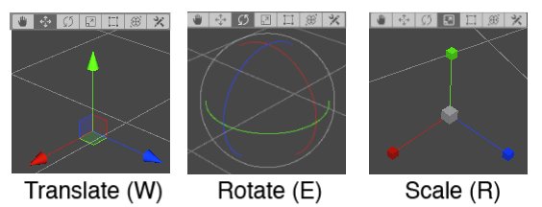

Figure ‎4‑6: *Transform gizmo*

### **4.5.1 Parenting**

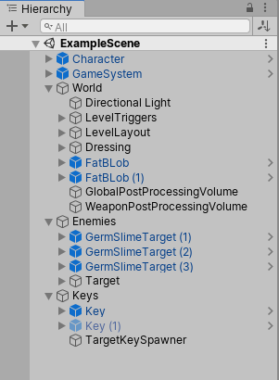Parenting is one of the most important concepts to understand when using Unity. When a GameObject is a Parent of another GameObject, the Child GameObject will move, rotate, and scale exactly as its Parent does. Parenting is like the relationship between arms and body; whenever the body moves, arms also move along with it. Child objects can also have children of their own and so on. So hands could be regarded as “children” of the arms and then each hand has several fingers, etc. Any object can have multiple children, but only one parent. These multiple levels of parent-child relationships form a Transform hierarchy. The object at the very top of a hierarchy (ie, the only object in the hierarchy that doesn’t have a parent) is known as the root. Parent can be created by dragging any GameObject in the Hierarchy View onto another. This will create a Parent- arenting is one of the most important concepts to understand when using Unity. When a GameObject is a Parent of another GameObject, the Child GameObject will move, rotate, and scale exactly as its Parent does. Parenting is like the relationship between arms and body; whenever the body moves, arms also move along with it. Child objects can also have children of their own and so on. So hands could be regarded as “children” of the arms and then each hand has several fingers, etc. Any object can have multiple children, but only one parent. These multiple levels of parent-child relationships form a Transform hierarchy. The object at the very top of a hierarchy (ie, the only object in the hierarchy that doesn’t have a parent) is known as the root. Parent can be created by dragging any GameObject in the Hierarchy View onto another. This will create a Parent-Child relationship between the two GameObjects.

Figure ‎4‑7: Example of a Parent-Child hierarchy. GameObjects with foldout arrows to the left of their names are parents.

* **Limitations with Non-Uniform Scaling:**

Non-uniform scaling is when the Scale in a Transform has different values for x, y, and z. For example, (2, 4, 2). In contrast, uniform scaling has the same value for x, y, and z. For example, (3, 3, 3). Non-uniform scaling can be useful in a few specific cases but it introduces a few oddities that don’t occur with uniform scaling which are:

Certain components do not fully support non-uniform scaling. For example, some components have a circular or spherical element defined by a radius property, among them Sphere Collider, Capsule Collider, Light and Audio Source. In cases like this the circular shape will not become elliptical under non-uniform scaling as you would expect and will simply remain circular.

When a child object has a non-uniformly scaled parent and is rotated relative to that parent, it may appear skewed or “sheared”. There are components that support simple non-uniform scaling but don’t work correctly when skewed like this. For example, a skewed Box Collider will not match the shape of the rendered mesh accurately.

For performance reasons, a child object of a non-uniformly scaled parent will not have its scale automatically updated when it rotates. As a result, the child’s shape may appear to change abruptly when the scale eventually is updated, say if the child object is detached from the parent.

### **4.5.2 Importance of Scale**

The scale of the Transform determines the difference between the size of a mesh in the modeling application and the size of that mesh in Unity. The mesh’s size in Unity (and therefore the Transform’s scale) is very important, especially during physics simulation. By default, the physics engine assumes that one unit in world space corresponds to one meter. If an object is very large, it can appear to fall in “slow motion”; the simulation is actually correct since effectively, a very large object falling a great distance. There are three factors that can affect the scale of the object:

* The size of mesh in the 3D modeling application.
* The Mesh Scale Factor setting in the object’s Import Settings.
* The Scale values of your Transform Component.

Ideally, the Scale of the object in the Transform Component should not be adjusted. The best option is to create models at real-life scale so there will be no need to change Transform’s scale. The next best option is to adjust the scale at which the mesh is imported in the Import Settings for an individual mesh. Certain optimizations occur based on the import size, and instantiating an object that has an adjusted scale value can decrease performance. [27]

## **4.6 Components**

Components are the nuts and bolts of objects and behaviors in a game. They are the functional pieces of every GameObject. As mentioned earlier, a GameObject is a container for many different Components. By default, all GameObjects automatically have a Transform Component. This is because the Transform dictates where the GameObject is located, and how it is rotated and scaled. Without a Transform Component, the GameObject wouldn’t have a location in the world. [28]

* **Adding Components**

Figure 4‑‎4‑8:An empty GameObject with a Rigidbody Component attached

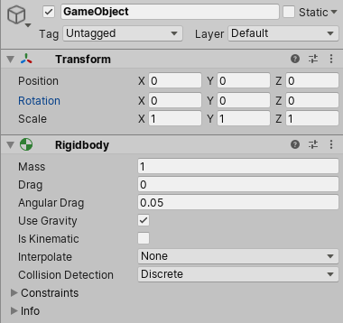Components can be added to the selected GameObject through the Components menu.

Figure ‎4‑9: *The Component Browser*

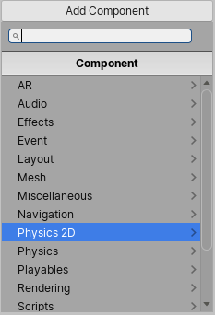Another option is to use the Component Browser, which can be activated with the Add Component button in the object’s inspector.

The browser allows navigating the components conveniently by category and also has a search box can be used to locate components by name. Any number or combination of Components can be added to a single GameObject. Some Components work best in combination with others. For example, the Rigidbody works with any Collider. The Rigidbody controls the Transform through the NVIDIA PhysX physics engine, and the Collider allows the Rigidbody to collide and interact with other Colliders.

* **Editing Components**

One of the great aspects of Components is flexibility. When a Component is attached to a GameObject, there are different values or Properties in the Component that can be adjusted in the editor while building a game, or by scripts when running the game. There are two main types of Properties: Values and References. In the image below. It is an empty GameObject with an Audio Source Component. All the values of the Audio Source in the Inspector are the default values.

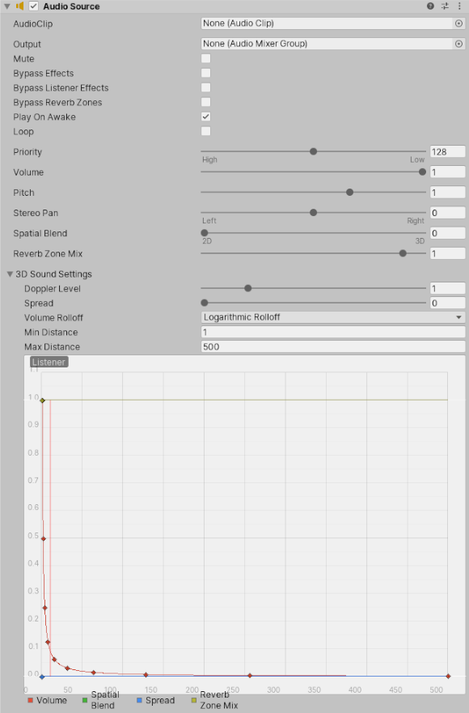

Figure ‎4‑10: Editing Components

This Component contains a single Reference property, and seven Value properties. Audio Clip  
is the Reference property. When this Audio Source begins playing, it will attempt to play the audio file that is referenced in the Audio Clip property. If no reference is made, an error will occur because there is no audio to be played. Thus, referencing the file within the Inspector should be done. This is as easy as dragging an audio file from the Project View onto the Reference Property or using the Object Selector.

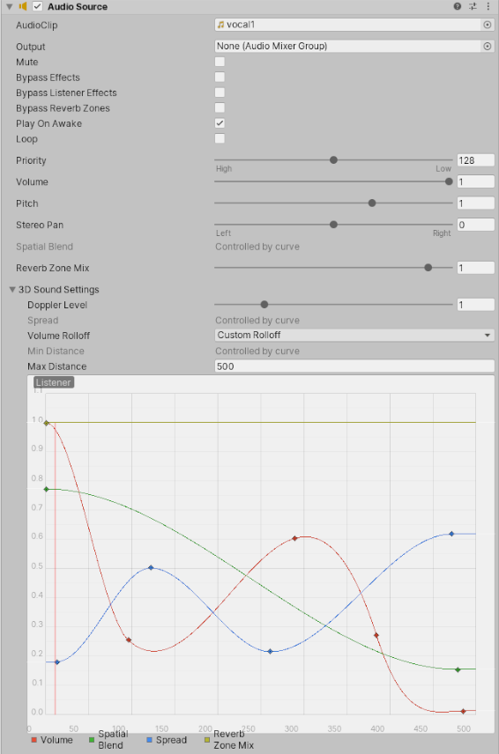

Figure ‎4‑11: Now a sound effect file is referenced in the Audio Clip property

The remaining properties on the Audio Clip are all Value properties. These can be adjusted directly in the Inspector. The Value properties on the Audio Clip are all toggles, numeric values, drop-down fields, but value properties can also be text strings, colors, curves, and other types.

* **Component Context Menu commands**

The context menu for a component has a number of useful commands.

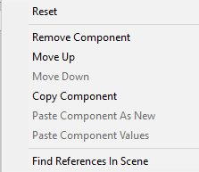

Figure ‎4‑12:The Component Context Menu

The same commands are also available from the kebab menu (3 vertical dots) icon in the extreme top-right of the component’s panel in the inspector.

Reset: This command restores the values the component’s properties had before the most recent editing session.

* **Remove**: A Remove Component command is available for cases where no longer need the component attached to the GameObject. There are some combinations of components that depend on each other such as [Hinge Joint](https://docs.unity3d.com/2020.3/Documentation/Manual/class-HingeJoint.html) only works when a [Rigidbody](https://docs.unity3d.com/2020.3/Documentation/Manual/class-Rigidbody.html) is also attached. A warning message appears when removing components that others depend on.
* **Move Up/Down:** Use the Move Up and Move Down commands to rearrange the order of components of a GameObject in the Inspector. Alternatively, click and drag the component’s name up or down in the Inspector window, and then drop it.
* **Copy/Paste**: The Copy Component command stores the type and current property settings of a component. These can then be pasted into another component of the same type with Paste Component Values. Also, new component with the copied values on an object by using Paste Component as New can be created. [29]

## **4.7 Static GameObjects**

If a GameObject does not move at runtime, it is known as a static GameObject. If a GameObject moves at runtime, it is known as a dynamic GameObject. Many systems in Unity can precompute information about static GameObjects in the Editor. Because the GameObjects do not move, the results of these calculations are still valid at runtime. This means that Unity can save on runtime calculations, and potentially improve performance.

* **The Static Editor Flags property**

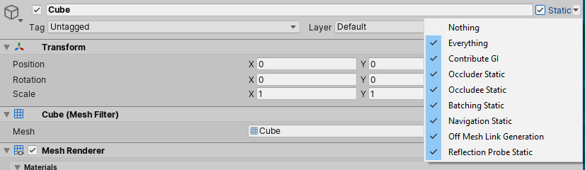

Figure ‎4‑13: The Static Editor Flags

The Static Editor Flags checkbox and drop-down menu, as seen when viewing a GameObject in the Inspector. The Static Editor Flags property lists a number of Unity systems which can include a static GameObject in their precomputations. Use the drop-down to define which systems should include the GameObject in their precomputations. Setting Static Editor Flags at runtime has no effect on these systems. GameObject should be included in the precomputations for systems that need to know about that GameObject. Including a GameObject in the precomputations for a system that does not need to know about that GameObject can result in wasted calculations, unnecessarily large data files, or unexpected behavior. The Static Editor Flags property is located in the Inspector for a GameObject, in the extreme top-right. It comprises a checkbox, which sets the value to Everything or Nothing, and a drop-down menu that lets you choose which values to include. Static Editor Flags property can be set in code, using the GameObjectUtility.SetStaticEditorFlags API, and the GameObject.isStatic. [30]

The following values are available:

|  |  |
| --- | --- |
| Property: | Function: |
| Nothing | Do not include the GameObject in precomputations for any systems. |
| Everything | Include the GameObject in precomputations for all systems below. |
| Contribute GI | When you enable this property, Unity includes the target [Mesh Renderer](https://docs.unity3d.com/2020.3/Documentation/Manual/class-MeshRenderer.html) in global illumination calculations. These calculations take place while precomputing lighting data at bake time. The ContributeGI property exposes the ReceiveGI property. The ContributeGI property only takes effect if you enable a global illumination setting such as [Baked Global Illumination](https://docs.unity3d.com/2020.3/Documentation/Manual/class-LightingSettings.html#MixedLighting) or [Realtime Global Illumination](https://docs.unity3d.com/2020.3/Documentation/Manual/class-LightingSettings.html#RealtimeLighting) for the target Scene . A Unity Blog post about static lighting with Light Probes provides guidance for using this flag. For additional context, see [this tutorial for setting up the Built-in Render Pipeline and lighting](https://docs.unity3d.com/2020.3/Documentation/Manual/BestPracticeLightingPipelines.html) in Unity. |
| Occluder Static | Mark the GameObject as a Static Occluder in the occlusion culling system. For more information, see the documentation on [the Occlusion Culling system](https://docs.unity3d.com/2020.3/Documentation/Manual/OcclusionCulling.html). |
| Occludee Static | Mark the GameObject as a Static Occludee in the occlusion culling system. For more information, see the documentation on [the Occlusion Culling system](https://docs.unity3d.com/2020.3/Documentation/Manual/OcclusionCulling.html). |
| Batching Static | Combine the GameObject’s Mesh with other eligible Meshes, to potentially reduce runtime rendering costs. For more information, see the documentation on [Static Batching](https://docs.unity3d.com/2020.3/Documentation/Manual/DrawCallBatching.html) . |
| Navigation Static | Include the GameObject when precomputing navigation data. For more information, see the documentation on [the Navigation system](https://docs.unity3d.com/2020.3/Documentation/Manual/nav-NavigationSystem.html). |
| Off Mesh Link Generation | Attempt to generate an Off-Mesh Link that starts from this GameObject when precomputing navigation data. For more information, see the documentation on [automatically building Off-Mesh Links](https://docs.unity3d.com/2020.3/Documentation/Manual/nav-BuildingOffMeshLinksAutomatically.html). |
| Reflection Probe | Include this GameObject when precomputing data for Reflection Probes whose Type property is set to Baked. For more information, see the documentation on [Reflection Probes](https://docs.unity3d.com/2020.3/Documentation/Manual/ReflectionProbes.html) . |

Table ‎4‑3: Set Static Editor Flags API

## **4.8 Rotation and Orientation**

Rotations in 3D applications are usually represented in one of two ways: Quaternions or Euler angles. Each has its own uses and drawbacks. Unity uses Quaternions internally but shows values of the equivalent Euler angles in the Inspector to make it easy to edit.

### **4.8.1 Euler angles**

Euler angles are represented by three angle values for X, Y and Z that are applied sequentially. To apply a Euler rotation to a particular GameObject, each rotation value is applied in turn, as a rotation around its corresponding axis.

* Benefit: Euler angles have an intuitive “human readable” format, consisting of three angles.
* Benefit: Euler angles can represent the rotation from one orientation to another through a turn of more than 180 degrees
* Limitation: Euler angles suffer from Gimbal Lock. When applying the three rotations in turn, it is possible for the first or second rotation to result in the third axis pointing in the same direction as one of the previous axes. This means a “degree of freedom” has been lost, because the third rotation value cannot be applied around a unique axis.

### **4.8.2 Quaternions**

Quaternions can be used to represent the orientation or rotation of a GameObject. This representation internally consists of four numbers (referenced in Unity as x, y, z & w) however these numbers don’t represent angles or axes and normally there is no need to access them directly. Unless there is a particularly interest in delving into the mathematics of Quaternions, it is only needed to know that a Quaternion represents a rotation in 3D space and there is no need to know or modify the x, y & z properties.

In the same way that a Vector can represent either a position or a direction (where the direction is measured from the origin), a Quaternion can represent either an orientation or a rotation - where the rotation is measured from the rotational “origin” or “Identity”. It is because the rotation is measured in this way - from one orientation to another - that a quaternion can’t represent a rotation beyond 180 degrees.

* Benefit: Quaternion rotations do not suffer from Gimbal Lock.
* Limitation: A single quaternion cannot represent a rotation exceeding 180 degrees in any direction.
* Limitation: The numeric representation of a Quaternion is not intuitively understandable.

Unity stores all GameObject rotations internally as Quaternions, because the benefits outweigh the limitations.

The Transform Inspector displays the rotation using Euler angles, because this is easier to understand and edit. Unity converts new values into the Inspector for the rotation of a GameObject into a new Quaternion rotation value for the GameObject.

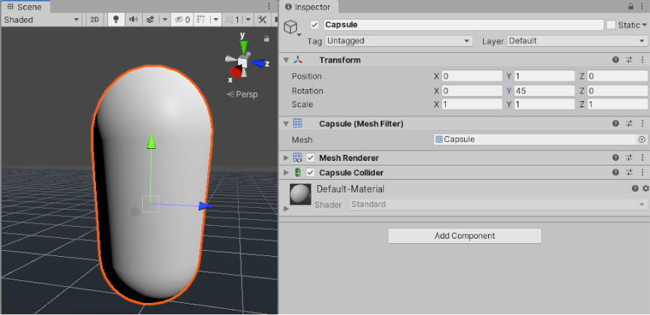

Figure ‎4‑14: GameObject scene

The rotation of a GameObject is displayed and edited as Euler angles in the Inspector, but is stored internally as a Quaternion. As a side-effect, it is possible in the Inspector to enter a value of, say, X: 0, Y: 365, Z: 0 for a GameObject’s rotation. This value is not possible to represent as a quaternion, so when entering Play mode, the GameObject’s rotation values change to X: 0, Y: 5, Z: 0. This is because Unity converts rotation to a Quaternion which does not have the concept of a full 360-degree rotation plus 5 degrees, and instead is set to orient the same way as the result of the rotation.

### **4.8.3 Implications for Animation**

Many 3D authoring packages, and Unity’s own internal Animation window, allow using Euler angles to specify rotations during an animation. These rotations values can frequently exceed ranges expressible by quaternions. For example, if a GameObject rotates 720 degrees, this could be represented by Euler angles X: 0, Y: 720, Z:0. But this is not representable by a Quaternion value.

### **4.8.4 Unity’s Animation Window**

Within Unity’s own animation window, there are options which allow to specify how the rotation should be interpolated - using Quaternion or Euler interpolation. Specifying Euler interpolation is telling Unity that full range of motion specified by the angles is needed. With Quaternion rotation however, put the rotation to end at a particular orientation, and Unity uses Quaternion interpolation and rotate across the shortest distance to get there.

### **4.8.5 External Animation Sources**

When importing animation from external sources, these files usually contain rotational keyframe animation in Euler format. Unity’s default behavior is to resample these animations and generate a new Quaternion keyframe for every frame in the animation, in an attempt to avoid any situations where the rotation between keyframes may exceed the Quaternion’s valid range.

For example, imagine two keyframes, 6 frames apart, with values for X as 0 on the first keyframe and 270 on the second keyframe. Without resampling, a quaternion interpolation between these two keyframes would rotate 90 degrees in the opposite direction, because that is the shortest way to get from the first orientation to the second orientation. However, by resampling and adding a keyframe on every frame, there are now only 45 degrees between keyframes so the rotation works correctly.

There are still some situations where - even with resampling - the quaternion representation of the imported animation may not match the original closely enough, for this reason, in Unity 5.3 and onwards there is the option to turn off animation resampling, so that you can instead use the original Euler animation keyframes at runtime. [31]

## **4.9 Physics**

* **Rigidbody:**

A Rigidbody is the main component that enables physical behavior for a GameObject. With a Rigidbody attached, the object will immediately respond to gravity. If one or more Collider components are also added, the GameObject is moved by incoming collisions. Since a Rigidbody component takes over the movement of the GameObject it is attached to, it should not be moved from a script by changing the Transform properties such as position and rotation. Instead, forces can be applied to push the GameObject and let the physics engine calculate the results.

There are some cases where a GameObject should have a Rigidbody without having its motion controlled by the physics engine. For example, to control a character directly from script code but still allow it to be detected by triggers. This kind of non-physical motion produced from a script is known as kinematic motion. The Rigidbody component has a property called Is Kinematic which removes it from the control of the physics engine and allow it to be moved kinematically from a script. It is possible to change the value of Is Kinematic from a script to allow physics to be switched on and off for an object, but this comes with a performance overhead and should be used sparingly. [32]

When a Rigidbody is moving slower than a defined minimum linear or rotational speed, the physics engine assumes it has come to a halt. When this happens, the GameObject does not move again until it receives a collision or force, and so it is set to “sleeping” mode. This optimization means that no processor time is spent updating the Rigidbody until the next time it is “awoken” (that is, set in motion again).

For most purposes, the sleeping and waking of a Rigidbody component happens transparently. However, a GameObject might fail to wake up if a Static Collider (that is, one without a Rigidbody) is moved into it or away from it by modifying the Transform position. This might result, say, in the Rigidbody GameObject hanging in the air when the floor has been moved out from beneath it. In cases like this, the GameObject can be woken explicitly using the Wakeup function.[32]

Collider components define the shape of a GameObject for the purposes of physical collisions. A collider, which is invisible, does not need to be the exact same shape as the GameObject’s mesh. A rough approximation of the mesh is often more efficient and indistinguishable in gameplay. The simplest (and least processor-intensive) colliders are primitive collider types. In 3D, these are the Box Collider, Sphere Collider and Capsule Collider. In 2D, you can use the Box Collider 2D and Circle Collider 2D. You can add any number of these to a single GameObject to create compound colliders.

* **Compound colliders**

Compound colliders approximate the shape of a GameObject while keeping a low processor overhead. To get further flexibility, additional colliders on child GameObjects can be added. For instance, rotating boxes relative to the local axes of the parent GameObject. When creating a compound collider like this, only use Rigidbody component is used, placed on the root GameObject in the hierarchy.

Primitive colliders do not work correctly with shear transforms. When using a combination of rotations and non-uniform scales in the Transform hierarchy so that the resulting shape is no longer a primitive shape, the primitive collider cannot represent it correctly.

* **Mesh colliders**

There are some cases, however, where even compound colliders are not accurate enough. In 3D, use Mesh Colliders can be used to match the shape of the GameObject’s mesh exactly. In 2D, the Polygon Collider 2D does not match the shape of the sprite graphic perfectly but the shape can be refined to any level of detail.

These colliders are much more processor-intensive than primitive types, so they should be used sparingly to maintain good performance. Also, a mesh collider cannot collide with another mesh collider (i.e., nothing happens when they make contact). This can be avoided in some cases by marking the mesh collider as Convex in the Inspector. This generates the collider shape as a “convex hull” which is like the original mesh but with any undercuts filled in.

The benefit of this is that a convex mesh collider can collide with other mesh colliders so this feature can be used when having a moving character with a suitable shape. However, a good rule is to use mesh colliders for scene geometry and approximate the shape of moving GameObjects using compound primitive colliders.

* **Static colliders**

Colliders can be added to a GameObject without a Rigidbody component to create floors, walls and other motionless elements of a Scene. These are referred to as static colliders. At the opposite, colliders on a GameObject that has a Rigidbody are known as dynamic colliders. Static colliders can interact with dynamic colliders but since they don’t have a Rigidbody, they don’t move in response to collisions.

* **Physics materials**

When colliders interact, their surfaces need to simulate the properties of the material they are supposed to represent. For example, a sheet of ice will be slippery while a rubber ball will offer a lot of friction and be very bouncy. Although the shape of colliders is not deformed during collisions, their friction and bounce can be configured using Physics Materials. Getting the parameters just right can involve a bit of trial and error but an ice material, for example will have zero (or very low) friction and a rubber material with have high friction and near-perfect bounciness.

* **Triggers**

The scripting system can detect when collisions occur and initiate actions using the OnCollisionEnter function. However, the physics engine can be used to detect when one collider enters the space of another without creating a collision. A collider configured as a Trigger (using the Is Trigger property) does not behave as a solid object and will simply allow other colliders to pass through. When a collider enters its space, a trigger will call the OnTriggerEnter function on the trigger object’s scripts

* **Collision callbacks for scripts**

When collisions occur, the physics engine calls functions with specific names on any scripts attached to the objects involved. Any code can be used in these functions to respond to the collision event. For example, playing crash sound effect when a car bumps into an obstacle.

On the first physics update where the collision is detected, the OnCollisionEnter function is called. During updates where contact is maintained, OnCollisionStay is called and finally, OnCollisionExit indicates that contact has been broken. Trigger colliders call the analogous OnTriggerEnter, OnTriggerStay and OnTriggerExit functions. Note that for 2D physics, there are equivalent functions with 2D appended to the name, eg, OnCollisionEnter2D.

With normal, non-trigger collisions, there is an additional detail that at least one of the objects involved must have a non-kinematic Rigidbody (ie, Is Kinematic must be switched off). If both objects are kinematic Rigidbodies then OnCollisionEnter, etc, will not be called. With trigger collisions, this restriction doesn’t apply and so both kinematic and non-kinematic Rigidbodies will prompt a call to OnTriggerEnter when they enter a trigger collider.

* **Collider interactions**

Colliders interact with each other differently depending on how their Rigidbody components are configured. The three important configurations are the Static Collider (ie, no Rigidbody is attached at all), the Rigidbody Collider and the Kinematic Rigidbody Collider.

* **Static Collider**

A static collider is a GameObject that has a Collider but no Rigidbody. Static colliders are mostly used for level geometry which always stays at the same place and never moves around. Incoming Rigidbody objects collide with static colliders but don’t move them.

In particular cases, the physics engine optimizes for static colliders that never move. For instance, a vehicle resting on top of a static collider remains asleep even if this static collider is moved. Static colliders can be enabled, disabled, or moved in runtime without specially affecting the physics engine computation speed. Also, a static Mesh Collider can safely scaled as long as the scale is uniform (not skewed).

* **Rigidbody Collider**

This is a GameObject with a Collider and a normal, non-kinematic Rigidbody attached. Rigidbody colliders are fully simulated by the physics engine and can react to collisions and forces applied from a script. They can collide with other objects (including static colliders) and are the most commonly used Collider configuration in games that use physics.

* **Kinematic Rigidbody Collider**

This is a GameObject with a Collider and a kinematic Rigidbody attached (ie, the IsKinematic property of the Rigidbody is enabled). You can move a kinematic rigidbody object from a script by modifying its Transform Component but it will not respond to collisions and forces like a non-kinematic rigidbody. Kinematic rigidbodies should be used for colliders that can be moved or disabled/enabled occasionally but that should otherwise behave like static colliders. An example of this is a sliding door that should normally act as an immovable physical obstacle but can be opened when necessary. Unlike a static collider, a moving kinematic rigidbody will apply friction to other objects and will “wake up” other rigidbodies when they make contact.

Even when immobile, kinematic rigidbody colliders have different behavior to static colliders. For example, if the collider is set to as a trigger then you also need to add a rigidbody to it in order to receive trigger events in your script. If you don’t want the trigger to fall under gravity or otherwise be affected by physics then you can set the IsKinematic property on its rigidbody. A Rigidbody component can be switched between normal and kinematic behavior at any time using the IsKinematic property.

A common example of this is the “ragdoll” effect where a character normally moves under animation but is thrown physically by an explosion or a heavy collision. The character’s limbs can each be given their own Rigidbody component with IsKinematic enabled by default. The limbs will move normallly by animation until IsKinematic is switched off for all of them and they immediately behave as physics objects. At this point, a collision or explosion force will send the character flying with its limbs thrown in a convincing way.

* **Collision action matrix**

When two objects collide, a number of different script events can occur depending on the configurations of the colliding objects’ rigidbodies. The charts below give details of which event functions are called based on the components that are attached to the objects. Some of the combinations only cause one of the two objects to be affected by the collision, but the general rule is that physics will not be applied to an object that doesn’t have a Rigidbody component attached. [33]

|  |  |  |  |  |  |  |
| --- | --- | --- | --- | --- | --- | --- |
| Collision detection occurs and messages are sent upon collision | | | | | | |
|  | Static  Collider | Rigidbody Collider | Kinematic Rigidbody Collider | Static Trigger Collider | Rigidbody Trigger Collider | Kinematic Rigidbody Trigger Collider |
| Static Collider |  | Y |  |  |  |  |
| Rigidbody Collider | Y | Y | Y |  |  |  |
| Kinematic Rigidbody Collider |  | Y |  |  |  |  |
| Static Trigger Collider |  |  |  |  |  |  |
| Rigidbody Trigger Collider |  |  |  |  |  |  |
| Kinematic Rigidbody Trigger Collider |  |  |  |  |  |  |

|  |  |  |  |  |  |  |
| --- | --- | --- | --- | --- | --- | --- |
| Trigger messages are sent upon collision | | | | | | |
|  | Static Collider | Rigidbody Collider | Kinematic Rigidbody Collider | Static Trigger Collider | Rigidbody Trigger Collider | Kinematic Rigidbody Trigger Collider |
| Static Collider |  |  |  |  | Y | Y |
| Rigidbody Collider |  |  |  | Y | Y | Y |
| Kinematic Rigidbody Collider |  |  |  | Y | Y | Y |
| Static Trigger Collider |  | Y | Y |  | Y | Y |
| Rigidbody Trigger Collider | Y | Y | Y | Y | Y | Y |
| Kinematic Rigidbody Trigger Collider | Y | Y | Y | Y | Y | Y |

Table ‎4‑4: Collision action matrix

* 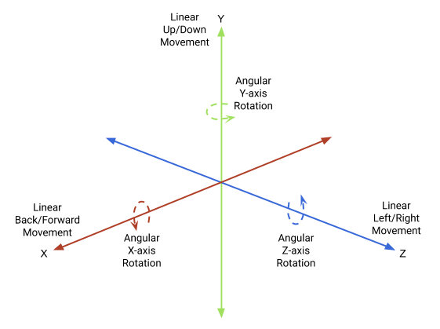**Joints:**

A Joint component connects a Rigidbody to another Rigidbody or a fixed point in space. Joints apply forces that move rigid bodies, and joint limits restrict that movement. Joints give Rigidbodies the following degrees of freedom:

Unity provides the following joints that apply different forces and limits to Rigidbody components, and therefore give those bodies different motion:

|  |  |
| --- | --- |
| Property: | Function: |
| Character Joint | Emulates a ball and socket joint, like a hip or shoulder. Constrains rigid body movement along all linear degrees of freedom, and enables all angular freedoms. Rigidbodies attached to a Character Joint orient around each axis and pivot from a shared origin. |
| Configurable Joint | Emulates any skeletal joint, like those in a ragdoll. You can configure this joint to force and restrict rigid body movement in any degree of freedom. |
| Fixed Joint | Restricts the movement of a rigid body to follow the movement of the rigid body it is attached to. This is useful when you need rigid bodies that easily break apart from each other, or you want to connect the movement of two rigid bodies without parenting in a Transform hierarchy. |
| Hinge Joint | Attaches a rigid body to another rigid body or a point in space at a shared origin and allows the rigid bodies to rotate around a specific axis from that origin. Useful for emulating doors and finger joints. |
| Spring Joint | Keeps rigid bodies apart from each other but lets the distance between them stretch slightly. The spring acts like a piece of elastic that tries to pull the two anchor points together to the exact same position. |

Table ‎4‑5: Joints Definitions

Joints also have other options that you can enable for specific effects. For example, joint can be set to break when a Rigidbody applies a force to it that exceeds a certain threshold. Some joints allow a drive force to occur between the connected Rigidbodies to set them in motion automatically. [34]

## **4.10 Character Controllers**

The character in a first- or third-person game will often need some collision-based physics so that it doesn’t fall through the floor or walk-through walls. Usually, though, the character’s acceleration and movement will not be physically realistic, so it may be able to accelerate, brake and change direction almost instantly without being affected by momentum.

In 3D physics, this type of behaviour can be created using a Character Controller. This component gives the character a simple, capsule-shaped collider that is always upright. The controller has its own special functions to set the object’s speed and direction but unlike true colliders, a rigidbody is not needed and the momentum effects are not realistic.

A character controller cannot walk through static colliders in a scene, and so will follow floors and be obstructed by walls. It can push rigidbody objects aside while moving but will not be accelerated by incoming collisions. This means that the standard 3D colliders can be used to create a scene around which the controller will walk without being limited by realistic physical behaviour on the character itself.

An Asset is a representation of any item that can be used in the project. This includes 3D models, image files (Textures), Materials, and audio. When creating an architecture visualization, for instance, furniture Assets such as chairs, tables and couches can be used, Ul elements like buttons, toggles and images, and sound effects as door opening, weather sounds and music. These Assets are subtle, but when combined, create an immersive environment.

There are three ways of adding and asset into Unity project. One of the most direct ways to access and import Assets into Unity projects is through the Unity Asset Store. The Asset Store is a growing library of both free and commercial Assets created by Unity Technologies and Unity members. Here, you can find Assets ranging from entire projects to individual objects, Materials/ Textures, animations, tutorials and everything in between. The second way is downloading assets from internet and importing them into the project. The third way is through working on 3D designing software if a specific design for the project is needed.[35]

Chapter Five

# **Brain Computer Interface**

Model evaluation is an essential phase in building engineering systems to ensure the quality and efficiency of the system. The proposed model is meant to replace the traditional mechanical labs that contain heave machines with a virtual-based technology that is assumed to be helpful in student’s understanding and interaction with machines. The challenge was how to evaluate the system so that student’s understanding can be indicated. After a lot of research, it’s found that a brain-computer interface (BCI) is the most suitable way to achieve that since it is widely used in applications similar to the one our team was working on.

BCI is a system that uses electrodes to establish direct communication between the brain and an external device such computer or robotic arm. There are two ways to establish a BCI system the invasive and non-invasive. The invasive requires a surgical operation to insert the electrodes under the patient’s skin. On the other hand, the non-invasive does not require that it is implemented by placing the electrodes on one’s scalp. Electroencephalography (EEG) is the most well-known technique in building a non-invasive BCI system that captures the brain's electrical activity. The simplicity of use, mobility, lower cost, and high temporal resolution are the main reasons for EEG popularity and what motivated the team to use it [36]. There are other alternatives, but they are not as efficient as the EEG.

BCI is used in many useful applications such as stress detection, motor imagery tasks, and spinal cord rehabilitation [37]. A typical BCI is used to retrieve data from the brain and send them to an external device to perform a certain task. In the proposed system BCI using EEG is only used to extract the signals and classify them to get specific information.

## **5.1 History of Brain-computer interface**

The story of BCI started in 1973 when the possibility of using electrical brain signals to control external machines was firstly questioned [38]. Although the research started earlier back in the 1960s with monkeys that showed signals from the brain can be used to move a meter needle [39], real investigations with humans began in the 1970s. Due to our shortage in the knowledge of the brain and limited computer capabilities, the progress of BCI took a long time. In 1980, it was demonstrated that the brain gives biofeedback of slow cortical potentials in EEG activity which can be used to move a rocket image vertically on a television screen [40]. The p 300 related event potentials could be used to make volunteers spell words from a screen as it was shown in 1988 [41]. By 2006, a microelectrode was implanted in the primary motor cortex in a man who suffers from complete tetraplegia. Using the signals obtained from this electrode, a BCI system helped the patient to unlock a simulated e-mail, use a television, open and close a prosthetic hand, and perform rudimentary actions with a robotic arm [42]. Moreover, signals that are recorded directly from the cortical surface can be used to make volunteers spell words from a screen [43]. BCI research is developing at an amazingly quick rate, as proven by the quantity of peer-reviewed papers in this field over the past ten years (Figure 5-1)

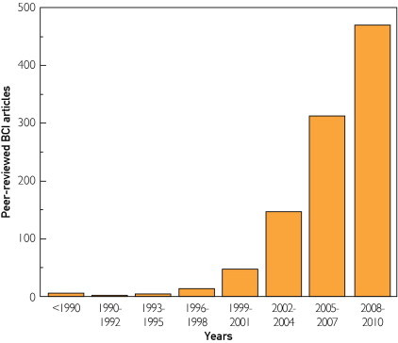

Figure ‎5‑1: Brain-computer interface articles in the peer-reviewed scientific literature.

## **5.2 Building a BCI system**

It can be inferred that brain-computer interface systems are gaining huge attention in scientific society due to their significant results in different specializations. These systems are often built and designed using electroencephalography (EEG), which allows for portable, flexible, and affordable devices [45]. A lot of research is directed towards developing more techniques and methods in building them. The process of designing an efficient BCI system, capable of accurately making predictions out of the input data, consists of data collection, data pre-processing, segmentation, feature extraction, feature selection, classification, and model evaluation [30,40]. These steps showed magnificent results in classifying stress levels in [36], motor imagery tasks in [37], and detecting situational interest in [47].

### **5.2.1 EEG Data collection**

Data collection is the first step in building BCI that can be achieved in multiple ways depending on the type of the project. The data are collected using brain sensors that are put directly on the subject’s scalp. The recent availability of EEG sensors makes the data collection process easier. For example, The NeuroSky “MindSet,”, is a headset that includes a single-channel EEG sensor [48]. It measures the voltage between an electrode that rests on the forehead and electrodes in contact with the ear. Although it only possesses a single channel, it is used in differentiating between two mental states with an accuracy of 86% in [49].

### **4.2.2 Signal processing**

EEG signals are very noisy, and it includes artifacts which make it challenging for engineers to use them as they require a lot of denoising and filtering techniques because they get affected by artifacts [44,45]. Artifacts are unwanted signals which are mainly resulted from environment noise, experimental error, and physiological artifacts. The environment artifacts such as power line interference are usually referred to as extrinsic artifacts and can simply be filtered using a notch filter. The notch filter is a reject filter used to bocks the transmission of a specific frequency range since its frequency is not consistent with the desired signals [52]. The experiment error can be avoided through good planning and setting for the experiment. On the other hand, the physiological artifacts that come from the body itself such as eye movement, muscle activity, and heartbeat. They are referred to as intrinsic artifacts and they require special techniques to be removed [47,48].

**Artifact Removal filtering Technique**

There are specific filters that are commonly used in artifact removals such as high pass filter, lowpass filter, and notch filter. They are all implemented using the Butterworth FIR filter [36]. Furthermore, the third-order median filter is always used to remove the background noise. Additionally, the signals are denoised using wavelets decomposition and smoothed using the digital filter Savitzky–Golay filter [49,50].

### **5.2.3 Signal Segmentation**

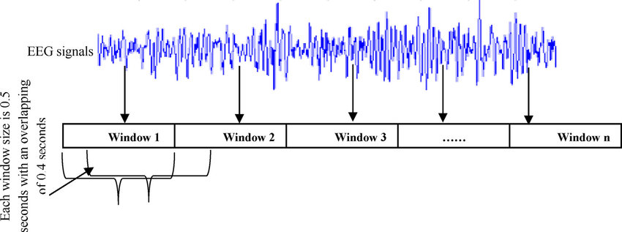EEG signals are divided into small portions or segments. This step plays an important role in attempting to make noisy EEG signals sound periodic. The segments are used afterward to extract features from them. The most commonly used approach in signal segmentation is the sliding window technique also known as the windowing technique. It uses a sliding window that loops over signals and extracts a small part of them in each step depending on the window size (Figure 5-2). There is a couple of ways to implement signal segmentation using the windowing technique the overlapping and non-overlapping.

Figure ‎5‑2: An example of segmenting an EEG signal into windows .

### **5.2.4 Feature Extraction**

To train a machine learning model, discriminative features are needed to be extracted. Features are different variables that are extracted from the data and can differentiate between the different activities of a dataset. These features are extracted from different domains such as the time domain, the frequency domain, and the time-frequency domain. The frequency domain can be obtained for a time-domain signal through the well-known Fourier transformation method. Whereas the time-frequency domain can be reached by using the wavelet transformation method. The common features that are extracted from the EEG signals are Mean value, Standard deviation, Median absolute deviation, Largest value, Smallest value, Energy measure, Interquartile range, Kurtosis, and entropy.

* **Data Pre-Processing**

Data pre-processing is a data mining technique that involves transforming raw data into an understandable format. Data usually contains missing values, outliers, categories, or names. The data pre-processing undergoes numerous steps like dealing with missing values, categorical data, splitting the data into a test set and training set, and feature scaling. The data sometimes include missing values that if they are not dealt with thoroughly replacing them with the mean value or dropping them, cause a problem in the classification process. Machine learning classifiers do not understand categorical data such as nationalities. Consequently, encoding these kinds of data is essential to get better results. Furthermore, the data is split into training and test sets to train the machine learning model. Lastly, feature scaling is required to make the classifier predict accurately.

### **5.2.5 Feature selection**

The feature extraction stage is importantly needed because the extracted features are of large dimensions which increases the BCI system’s classification step’s complexity and usually reduces its performance. Therefore, FS is needed to reduce the computational cost. There are three types of feature selection techniques which are filter, wrapper, and embedded. The filter uses a metric to evaluate features and accordingly select them. It is fast but independent of the classification process. The wrapper sends the features to the classifier to get feedback, but it is slower than the filter technique. In the embedded method, the FS process is inserted within the classifier structure. The embedded FS technique comprises the interface within the classification process. It requires less execution time than the wrapper FS method. Additionally, the principal component analysis PCA is also one of the most used methods in selecting EEG features.

### **5.2.6 Classification**

After the feature selection process, the selected features need to be trained so that activities with close values to them can be classified correctly. This step is implemented by machine learning. Machine Learning is a branch of artificial intelligence (AI) that helps provide systems with the ability to learn and improve from previous experience and data without being explicitly programmed to do that. The process of learning begins with observations or data, such as examples, direct experience, or instruction, in order to look for patterns in data and make better decisions in the future based on the examples that we provide. The aim is to make computers learn by themselves without any human intervention.

Machine learning classifiers are categorized as supervised and unsupervised depending on the way they get trained. Supervised machine learning algorithms can apply what has been learned in the past to new data using labelled examples to predict future events. Starting from the analysis of a known training dataset, the learning algorithm produces an inferred function to make predictions about the output values. The system can provide targets for any new input after sufficient training. The learning algorithm can also compare its output with the correct, intended output and find errors to modify the model accordingly. In contrast, unsupervised machine learning algorithms are used when the information used to train is neither classified nor labelled. Unsupervised learning studies how systems can infer a function to describe a hidden structure from unlabelled data. The system doesn’t figure out the right output, but it explores the data and can draw inferences from datasets to describe hidden structures from unlabelled data [58].

There are certain machine learning classifiers that are often used in EEG classifications such as Decision Tree, Naive Bayes Classifier, K-Nearest Neighbours, and Support Vector Machines. A machine learning classifier is an algorithm that classifies data by dividing them into classes. A decision tree is a supervised machine learning classification algorithm that is used to create models that resemble tree structures. It divides data into finer and finer categories, such as "tree trunk," "branches," and "leaves." It employs the if-then rule to establish sub-categories that fit into broader categories, allowing for accurate, organic categorization. The Naive Bayes family of probabilistic algorithms determines the likelihood that any given data point falls into one or more of several categories (or not). In-text analysis, Naive Bayes is used to grouping consumer feedback, news stories, emails, and other types of content into subjects, topics, or "tags" based on pre-defined criteria.

K-nearest neighbours (k-NN) is a pattern recognition algorithm that calculates how training data points correspond to other data in n-dimensional space and stores and learns from them. In the future, K-NN aims to find the k closest related data points. In-text analysis, k-NN assigns a word or phrase to a predetermined group by measuring its nearest neighbour: k is determined by a majority vote of its neighbours. If k = 1, it will be assigned to the class that is closest to 1. SVM algorithms classify data and train models within super-finite degrees of polarity, resulting in a three-dimensional classification model that extends beyond X/Y predictive axes. To better understand how SVM algorithms operate, take a look at this visual representation. We have two tags: red and blue, as well as two data features: X and Y, and we train our classifier to produce either red or blue as an X/Y coordinate.

The SVM assigns a hyperplane to each tag that best separates them. This is just a straight line in two dimensions. The best hyperplane for machine learning model training is the one with the greatest distance between each. SVM algorithms make excellent classifiers because, the more complex the data, the more accurate the prediction will be.

### **5.2.7 Model evaluation**

Now, the machine learning model was built and trained but it must be evaluated to test how efficient it is. There are four different types of outcomes that can happen while making classification predictions [59].

1. True positives are when you predict an observation belongs to a class and it does belong to that class.
2. True negatives are when you predict an observation does not belong to a class and it does not belong to that class.
3. False positives occur when you predict an observation belongs to a class when in reality it does not.
4. False negatives occur when you predict an observation does not belong to a class when in fact it does.

On a confusion matrix, these four outcomes are often plotted. The confusion matrix below (figure 5-3) illustrates the case of binary classification. After making predictions on test data and describing each prediction as one of the four possible outcomes mentioned above. The three main metrics used to evaluate a classification model are accuracy, precision, and recall. The percentage of accurate predictions for the test data is known as accuracy. It is easy to figure out by dividing the number of valid predictions by the total number of predictions, as in (1) [59].

Accuracy = $\frac{Correct predictions}{All predictions }$

(1)

Precision is classified as the percentage of relevant examples (true positives) among all the examples predicted to belong to a specific class, as in (2).

Precision = $\frac{True Positive }{True Positive+False Positive }$

(2)

The recall is defined as the fraction of examples that were predicted to belong to a class concerning all of the examples that truly belong in the class.

Recall = $\frac{True Positive }{True Positive+False Negative }$

(3)

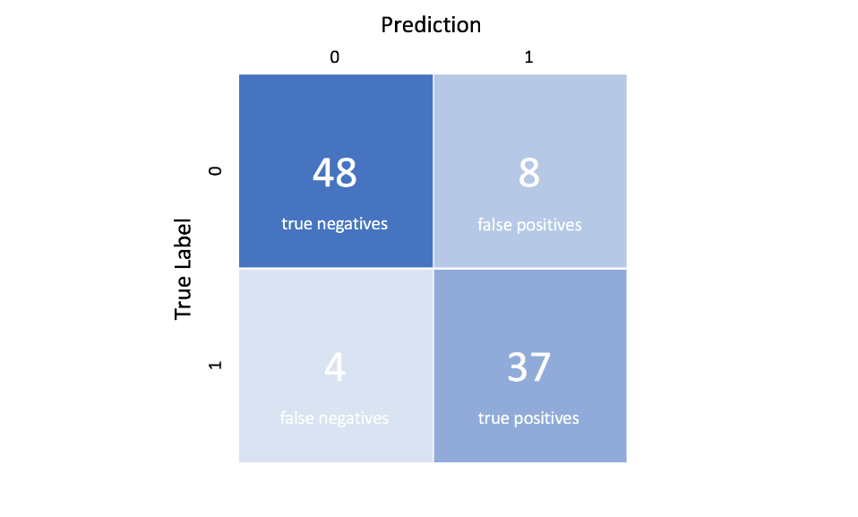

Figure ‎5‑3: The confusion matrix

## **5.3 BCI Literature review**

Brainwave experiments used to take a long time to prepare, and they often involved the use of gel to secure electrodes to the experimental subject's head. Because of these factors, conducting brainwave studies in the classroom was difficult. However, as technology progresses, EEG equipment becomes more compact and portable, making it possible to obtain precise brainwave data with easy planning. For example, authors in [60] used Emotiv EPOC neuroheadset to track the participants' brainwaves and provide neurofeedback as a treatment for ADHD.

The authors in [61] investigated the effects of visual focus and reading time on children and adults reading printing picture books using the NeuroSky MindBand. In [62] the NeuroSky MindSet headset was used in a mobile reading context to examine how learner focus states changed when they were faced with the same learning material in three different reading situations (sitting, standing, and walking). The authors of [57,58] used EEG to assess participants' sustained attention while reading on the internet. Authors in [65] demonstrated a portable EEG sensor-based technique for non-disturbing real-time automated measurement and analysis of learner motivation in game-based learning. [66] also used the Emotiv EPOC neuroheadset to assess learners' motivation and engagement when playing an educational game designed to teach a chemistry lesson. This game, known as LewiSpace, is a 3D environment that aims to balance between playful and educational content so as to boost interaction and motivation.

### **5.3.1 EEG data collection in education**

Internalization of positive attitudes about course material, subject matter, or the teacher is referred to as affective learning [67]. In [68] The authors created a simulated distance education environment and recorded learners' EEG signals as they browsed the website. They also take alpha waves (a part of EEG signals) and combine them with the website's ontology. The EEG signal from students who were emotionally stimulated by the web pages was recorded using Nexus and BioTrace+ software. Second, they use a Mysql database to monitor user behavior to investigate their active characteristics and modes.[69] shows the impact of Computational Thinking (CT) education on problem-solving capacity and how it affects students' cognitive load in problem-solving situations. CT education was given to 16 undergraduate students throughout ten sessions and a total of 30 hours. The courses were specifically designed to apply the CT method to problem-solving situations.

Participants' CT ability was assessed before and after the teaching of entire courses for two groups: CT group and Not-CT (NCT) group, to assess the influence of CT education. EEG was also used to monitor how the learners' cognitive load changed during problem-solving processes using the Fp1 and Fp2 channels. According to the findings, students who studied with a CT-based program scored higher on a CT-based problem-solving exam. In terms of EEG performance, the CT group had a lower SEF-95 percent than the NCT group. A pre-knowledge test is used to measure the problem-solving ability before the course. The post-CT-based problem-solving test with problem isomorphs was given after the ten sessions. Participants in both groups have better records than they did before the exam. The CT group, in particular, performs better in the questions that assess solution strategy.

In [70] the authors collected EEG signal data from college students as they viewed MOOC video clips. they selected online education videos that are unlikely to be frustrating to college students, such as videos of simple algebra or geometry introductions. they also selected videos that are intended to perplex a typical college student who is unfamiliar with topics such as Quantum Mechanics and Stem Cell Research. The authors created a total of 20 videos, with ten in each group. Each video lasted about two minutes. To make the videos more complicated, the two-minute clip was cut in the middle of a topic. they gathered information from ten students. A ten-session experiment with a student was conducted. they chose five videos from each group at random and randomized the presentation sequence so the student couldn't guess the predetermined level of confusion.

After each session, the student rated his or her level of confusion on a scale of 1 to 7, with 1 indicating the least confusing and 7 indicating the most confusing. In addition, three student observers were observing the student's body language. On a scale of 1 to 7, each observer rated the student's level of uncertainty in each session. A standard scale of 1 to 7 was used. Four observers were assigned to observe one to eight students each, to avoid the effect of observers focusing solely on one student. After classifying the collected data, the accuracy was 67%. In [47] authors used EEG signals to measure student’s situational interest while learning in a classroom. The participants were chosen from the foundation and first-year undergraduate students who completed a questionnaire about entering the university's mathematics club. The questionnaire was used as a pre-evaluation to determine the degree of personal/individual interest among students, and a balanced group of participants with strong, low, and moderate interest was chosen.

In total, 43 students (5 females) took part in this study. Selected participants were informed by email and given a detailed explanation of the experiment. Three classroom experiments were conducted, each of which was split into two sections. Lecturers who teach similar courses at the university gave 16 to 22-minute presentations in each session. A pre-knowledge test and an individual interest questionnaire were given after participants arrived and signed the consent document. Following the EEG recording, a Situational Interest (SI) questionnaire was completed, as well as a post-knowledge test. The post-knowledge test (which contains the same questions as the pre-knowledge test) was used to assess the lecture's knowledge.

In [71] the authors used EEG to distinguish between students who answer exam questions correctly and those who did not know the answer. As illustrated in (Figure 5-4), the study included six stages of experiments. A description of how the trial would progress was presented during the pre-experiment explanation stage. Participants were also instructed to keep their movements to a minimum and avoid blinking as much as possible during the EEG recording session. During the first rest time, participants were asked to refrain from looking at or thinking about a specific object for 60 seconds. The baseline recording guideline for the EmotivPro software was followed, which includes six steps in the baseline EEG measuring stage for 40 seconds. After then, there were another 30 seconds of rest.

 The primary problem-solving experiment was the following step. It included ten questions to be answered. The participants were given 60 seconds to complete each problem and go on to the next task if they didn't know the solution. For each question in the test, the last two processes, rest and problem solving, were repeated. Finally, the experiment participants were interviewed after the experiment.

Figure ‎5‑4: Description of experiment procedures in[42]

## **5.4 THE proposed system**

### **5.4.1 Data collection**

The data collection experiment was designed based on the previous related work. On projects like the proposed one, subjects’ EEG data is collected from them when they are using the system. Thereafter, the data are labelled using a post-knowledge test.

The experiment used consists of two phases. The first one is the subject using the proposed system while putting the EEG headset on. Then, to measure his/her knowledge and attitude, a knowledge and attitude questionnaire is used. The knowledge and attitude were chosen specifically to test how effective the proposed system is and the advantage it adds over the typical lab in terms of safety, concentration, and physical interaction with the machine.

The questionnaire we used consisted of 10-likert questions. Each question has five choices, strongly disagree, disagree, neutral, agree, and strongly agree. The questions were designed to test student’s interest in the content through questions that measures his/her interaction during using the system. Moreover, there were some other questions that were knowledge based. After recording the EEG signal, student’s answers were analysed and based on the mean, the answers were used to label the EEG signals by dividing them into two classes. Class zero students who were not interest and class one those who were not interested. The results of the experiment are summarized below (Table 5-1):

|  |  |  |
| --- | --- | --- |
| Number of students | Interested | Not interested |
| 6 | 3 | 3 |

Table ‎5‑1: Questionnaire results

To have a balanced interest level among participants, students from different engineering majors were selected. They were asked if they’re interested to participate in the experiment and those who showed interest were selected. When they arrived at the experiment place, they were informed of everything about the experiment, how they can use the system and control the engine, and they were asked to answer the post-knowledge and attitude questionnaire honestly with no guessing. After that, they signed up a consent that they agreed on volunteering in our experiment and using the collected data for research purposes. They started to use the system while putting the EEG headset on to record their brain activity using the neurosky one-channel sensor at a sampling frequency of 50 HZ. Finally, they answered the post-knowledge and attitude questionnaire. Participants’ demographics are summarized below (Table 5-2).

|  |  |  |  |
| --- | --- | --- | --- |
| Participant | Gender | Major | Age |
| 1 | Male | Mechanical | 24 |
| 2 | Male | Electronics and communication | 22 |
| 3 | male | Mechanical | 23 |
| 4 | Male | Electronics and communication | 22 |
| 5 | Male | Mechatronics | 23 |
| 6 | Male | Construction | 23 |

Table ‎5‑2: Participants’ Demographics

### **5.5.2 Data preparation & exploration**

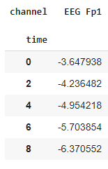In the data preparation phase, the raw data was prepared to work with it in python. After importing the data of all participants, it was stored in one dictionary with keys that were named the same as each participant’s id. (figure 5-5) is an example of the first 8 rows of the record of channel Fp1 of subject_01. Afterward, part of the data was visualized with the aim of exploring the data and picturing the effect of signal processing. Moreover, to test whether the data has outliers or not. The data was plotted using histograms. The first three seconds of subject_01 one channel data are shown in (figure 4-5). The distribution of the EEG FP1 channel is shown in(figure 4-6).

Figure ‎5‑5: part of the data

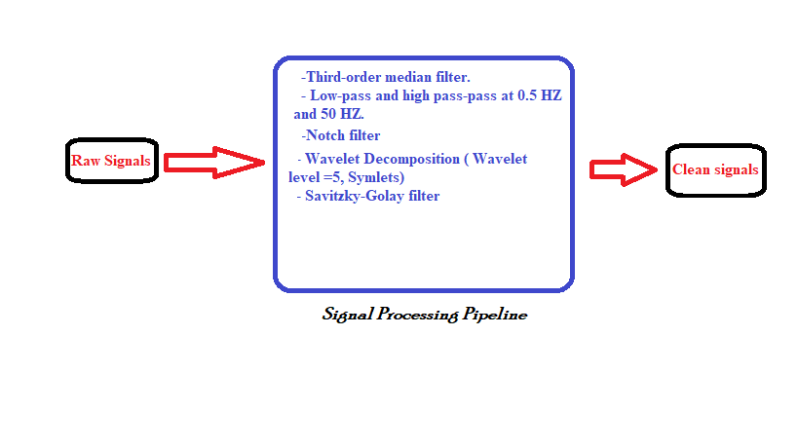

Figure ‎5‑6: The BCI Pipeline

### **5.5.3 Signal processing**

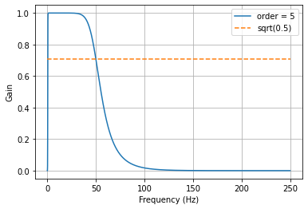The signal processing methods applied in the proposed system are the same as the authors in [36] used. The filters are defined using the Scipy package to remove artifacts. The filters used are third-order median filter, low pass filter, high pass filter, and notch filter. For denoising and smoothing, wavelet denoising, and a Savitzky–Golay filter were used. First, the raw signals were filtered using the third-order median filter to remove the background noise. then, the filtered signals were further filtered using low-pass and high-pass filters. A Butterworth filter with order 5 was used to design these filters at cutoff frequencies of 0.5 HZ and 50 HZ for the low and high filters respectively. The Butterworth filter is a signal processing filter with a frequency response in the passband that is as flat as possible. A maximally flat magnitude filter is another name for it. (figure 5-7) shows the designed bandpass filter using both the low pass and high pass filters. (figure 5-8) shows the result of applying the Butterworth filter on a sample of the data.

Figure 5-7: The Butterworth filter

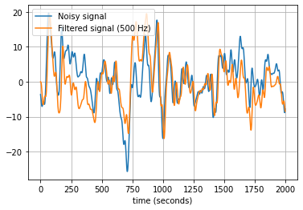

Figure 5-8: band-pass filter

Subsequently, a notch filter was applied to reject power interference at 60 HZ. Furthermore, the signals were denoised using a de-noising method based on multilevel wavelet decomposition. The number of wavelet levels was 5, the mother wavelet was Symlets. Lastly, the signals were smoothed using the Savitzky–Golay filter. Figure(5-8,9) presents the result of the signal processing techniques applied to the proposed system.

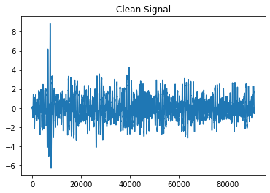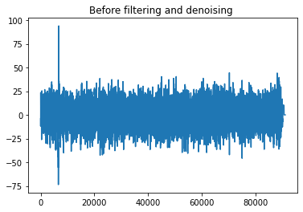

Figure 5-9: Denoised Signal

Figure 5‑8: Noisy Signal

### **5.5.4 Windowing**

After filtering the signals, the clean signals were segmented using a sliding window. The process involved some steps. First, a 4-second width window was used to loop through the time-domain signal dividing it into small segments for 4 seconds each. The window width was decided based on the literature done. To decide whether the sliding window has to be overlapping or non-overlapping, both methods were tried. The result was that the overlapping method was more efficient and resulted in higher accuracy. We started with a 50% overlap. then, we tried different values until the highest accuracy was achieved at a 4-second sliding window and 3-second overlap.

The segments after that were converted from the time-domain to the frequency-domain using the Fast Fourier transform. In addition to that, the signals were obtained in the time-frequency domain as stated in [36] the features extracted in the time-frequency domain result in getting a higher classification accuracy. The Wavelet transformation was used in converting the signals to the time-frequency domain.

### **5.5.5 Feature Extraction**

The features extracted from each column in time, frequency, and time-frequency domains were:

The mean x̄ of a data set is the sum of all the data divided by the count n.

$$\frac{Sum of terms}{number of terms }$$

(4)

The standard deviation is a statistic that measures the amount of variation or dispersion in a set of numbers. A low standard deviation implies that the values are close to the set's mean, whereas a high standard deviation shows that the values are dispersed across a larger range.

$$σ= √∑\frac{X_{i }-μ}{N}$$

(5)

$σ$ = population standard deviation

N = the size of the population

$X_{i }$ = each value from the population

$μ$ = the population mean

In statistics, the median absolute deviation is a robust measure of the variability of a univariate sample of quantitative data. It can also refer to the population parameter that is estimated by the MAD calculated from a sample.

median absolute deviation= $|X_{i }-mean|$

(6)

X_i = each value

In descriptive statistics, the interquartile range, also called the midspread, middle 50%, or H‑spread, is a measure of statistical dispersion, being equal to the difference between 75th and 25th percentiles, or between upper and lower quartiles. In information theory, the entropy of a random variable is the average level of "information", "surprise", or "uncertainty" inherent in the variable's possible outcomes. In addition to the minimum and maximum value in each column. The entropy, energy, skewness, and kurtosis features that work well in classifying EEG data were also extracted from the data in the three domains.

### **5.5.6 Feature reduction and selection**

After feature extraction, feature reduction was done to the data to reduce the high dimensionality that slows down the system. The dimensionality reduction was implemented using PCA the principal components analysis. PCA is an unsupervised linear transformation approach that is widely utilized in a variety of domains, with the most common applications being feature extraction and dimensionality reduction. PCA is also used for exploratory data analysis and signal de-noising in stock market trading, as well as the study of genome data and gene expression levels in the field of bioinformatics.

After feature reduction, the features were further reduced using the step forward feature selection method. Step forward feature selection begins by evaluating each feature and selecting the one that produces the highest performing algorithm model.

### **5.5.7 Classification**

Four machine learning classifiers were used to classify the EEG data the LinearDiscriminantAnalysis, support vector machines, random forest, and KNN. After getting split into training and test sets, the training data was fed into the classifiers and the test set was used to measure the classifier's accuracy.

### **5.5.8 Results**

To Evaluate models’ performances, accuracy, sensitivity, and the F1 score were used. The results are divided into three categories the result without feature reduction and feature selection, with feature selection, and with feature selection and reduction. The results of each category were evaluated using the metrics above and the classification computational cost.

* **The results without feature reduction and feature selection**

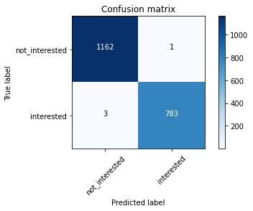Without feature reduction and selection, the SVM has the highest performance with an accuracy of 99.7%, a sensitivity of 99.6%, a recall of 99%, and a f1-score of 99%. The LDA has the lowest accuracy of 96.3%. On the other hand, the random forest has the lowest recall and f1-score as shown in (Table 5-3). However, the classification computational cost time was 23.86 seconds. The confusion matrix in (Figure 5-10) shows the classification result of SVM. It correctly predicted 1162 and 783 of class zero and class one, respectively.

**Figure 5-10: The confusion matrix without Feature reduction and selection**

|  |  |  |  |  |
| --- | --- | --- | --- | --- |
|  | Accuracy | Sensitivity | Recall | f1-score |
| LinearDiscriminantAnalysis | 96.3% | 93.1% | 96% | 96% |
| support vector machines | 99.7% | 99.6% | 99% | 99% |
| random forest | 97.6% | 99.4% | 88% | 88% |
| K-NN | 97.6% | 99.4% | 96% | 96% |

Table ‎5‑3: Model Results without Feature reduction & Feature Selection

* **The results with feature selection only**

By using the step forward feature selection technique, it turned out that the SVM evaluation parameters have increased from an accuracy of 99.7% to 99.8%, a sensitivity of 99.6% to 99.7%, a recall of 99% to 99.9, and a f1-score of 99% to 99.9%. On the other hand, the parameters of random forest have decreased remarkably (97.6% to 68.2% accuracy). The K-NN parameters like SVM have increased to reach an accuracy of 99.5% from 97.6%. Furthermore, the classification computational cost time reduced from 23.86 to 15.5 seconds. The results are shown in (Table 5-4). The confusion matrix in (Figure 5-11) shows the classification result of SVM. It correctly predicted 1162 and 783 of class zero and class one, respectively.

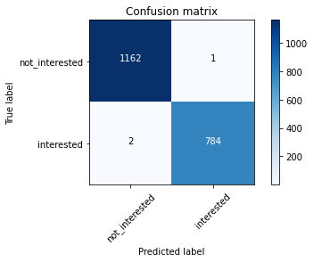

**Figure 5-11: The confusion matrix in case of FS only**

|  |  |  |  |  |
| --- | --- | --- | --- | --- |
|  | Accuracy | Sensitivity | Recall | f1-score |
| LinearDiscriminantAnalysis | 93.2% | 86.5% | 93% | 93% |
| support vector machines | 99.8% | 99.7% | 99.9% | 99.9% |
| random forest | 68.2% | 17.1% | 63% | 56% |
| K-NN | 99.5% | 99.8% | 99.9% | 99.9% |

Table ‎5‑4: The results with feature selection only

* **The results with feature reduction and feature selection**

After reducing the features from 23 to 13 using the PCA, the features were then selected using the step forward feature selection technique that selected the best performing 8 features in each classifier. Thereafter, the selected features were used to train the classifier. The SVM is still with the highest performance, but its evaluation parameters have decreased the same is also for the KNN. On the contrary the random forest’s evaluation parameters have increased significantly from an accuracy of 68.2% to 95.3%, a sensitivity of 17.1% to 95.2%, a recall of 63% to 95%, a f1-score of 56% to 95%. The classification computational cost was even reduced from 15.5 to 15 seconds. The results are summarized in (Table 5-5). The confusion matrix in (Figure 5-12) shows the classification result of SVM. It correctly predicted 1154 and 781 of class zero and class one, respectively.

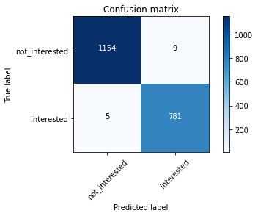

**Figure 5‑12: The confusion matrix of SVM in case of Feature reduction and Selection**

|  |  |  |  |  |
| --- | --- | --- | --- | --- |
|  | Accuracy | Sensitivity | Recall | f1-score |
| LinearDiscriminantAnalysis | 80% | 67% | 80% | 80% |
| support vector machines | 99.2% | 99.3% | 99% | 99% |
| random forest | 95.3% | 95.2% | 95% | 95% |
| K-NN | 97.7% | 98.2% | 98% | 998% |

Table ‎5‑5: The results with feature reduction and feature selection

The last step was model validation that was done to test the system against overfitting using K-fold cross-validation. A limited dataset is divided into k non-overlapping folds using the k-fold cross-validation process. Each of the k folds is given the chance to be used as a held back test set, while the rest of the folds are combined to form a training dataset. On the k hold-out test sets, a total of k models is fitted and evaluated, and the mean performance is reported. The mean of accuracies is calculated, and the results showed that the SVM has the highest average accuracy of 99% unlike the LDA that has the lowest average accuracy of 79.5%. The results are shown in (Table 5-6)

|  |  |
| --- | --- |
|  | Accuracy |
| LinearDiscriminantAnalysis | 79.51 % |
| support vector machines | 99.40 % |
| random forest | 97.90 % |
| K-NN | 99.10 % |

Table ‎5‑6: K-fold cross-validation results

Chapter Five

# **Conclusion and future work**

The world is going to digitalize everything depending on the power of computers and the level of advancement the technology has reached recently. There are thousands of papers are published yearly that use technology in every aspect of life including education. Due to fact that the coronavirus pandemic stopped normal life activities on earth, the idea of using technology in providing an effective way of resuming the educational process the same way it was before the pandemic came up to the team. The solution represented in building a heavy machine lab in the virtual reality to help engineering students keep acquiring their practical knowledge in remote learning.

The proposed system went through three phases designing the marine diesel engine, using The unity VR engine to get the engine into the VR environment, and evaluating the system through designing a brain-computer interface system (BCI). The BCI used students’ EEG signals while using the engine in the VR to measure his/her interest. Hence, it can be inferred whether the proposed system is as effective as the real lab on campus or not.

In conclusion, after building our first model, the results were significant as students enjoyed using the system and showed high interest in it. Moreover, the BCI system can predict a student’s interest through his/her EEG signal with an accuracy of up to 99%.

## **6.1 Future work**

The future work following this project is working further on improving the design and adding more options to the simulation. As per the mechanical design part, it is planned to add fuel system simulation, starting from the fuel tank following up until fuel injection in the cylinder head. Lubrication system is also in the plan to be added to the design and VR simulation, starting from the oil storing tank up until to the bed plate and lubrication of the crankshaft, pistons, camshaft and cylinder block. Engine Performance Analysis is to be added to the simulation so that different inputs are measured against their resulting outputs in the engine.

The ultimate goal after these small steps is to simulate all educational workshops in the Academy so that students can have what they need to learn effectively and safely, interactively on the VR.

# **REFERENCES**

[1] Burroughs, A. (2018, June). UBTech 2018: Higher Ed Sees Great Potential in Virtual Reality. Retrieved from: <https://edtechmagazine.com/higher/article/2018/06/ubtech-2018-higher-ed-sees-great-potential-virtual-reality>

[2] Ericksen, K. (2020, September). Exploring the Future of Augmented Reality & Virtual Reality in Higher Ed. Retrieved from: <https://collegiseducation.com/news/technology/augmented-reality-and-virtual-reality-in-higher-ed/>

[2] Thompson, S. (2020, February). VR in Higher Education: with Examples. Retrieved from: <https://virtualspeech.com/blog/vr-education-example-use-cases>

[3] mbryonic. (n.d.). Why VR Is The Perfect Education Tool. Retrieved from: <https://mbryonic.com/vr-education/>

[4] Bengfort, J. (2020, February). Virtual Reality Advances Bring New Possibilities to Higher Education. Retrieved from: <https://edtechmagazine.com/higher/article/2020/02/virtual-reality-advances-bring-new-possibilities-higher-education>

[5] The University of Sydney. (n.d.). Immersive Learning Laboratory. Retrieved from: <https://www.sydney.edu.au/engineering/our-research/laboratories-and-facilities/immersive-learning-laboratory.html>

[6] Ijaz, K. Marks, B. Hartley, T. Gibbens, P. Thomas, J. (2017). The Immersive Learning Laboratory: employing virtual reality technology in teaching. Retrieved from: <https://aaee.net.au/wp-content/uploads/2018/09/AAEE2017-Thomas_Ijaz_Marks_et_al-Employing_virtual_reality_technology_in_teaching.pdf>

[7] Fox Valley Technical College. (2017, November). Diesel Tech Programs Add Virtual Engine. Retrieved from: <https://www.fvtc.edu/news/story/diesel-tech-programs-add-virtual-engine>

[8] Santosnm. (2019, December).

[9] How Virtual Reality helps Classrooms. Retrieved from: https://blogs.stockton.edu/msantoseducationblog/

[10] [Anish](https://www.marineinsight.com/author/anishw/). (2021, January). Types of Piston Rings and Piston Ring Maintenance. Retrieved from: <https://www.marineinsight.com/guidelines/types-of-piston-rings-and-piston-ring-maintenance/>

[11] Student Lesson (2020, July). Everything you need to know about automobile piston. Retrieved from: <https://studentlesson.com/piston-definition-parts-functions-materials-issue-working/>

[12] Yamagata, H. (2014, March). The Science and Technology of Materials in Automotive Engines. Retrieved from: <https://www.sciencedirect.com/science/article/pii/B9781855737426500087>

[13] X-engineer.org. (n.d.) Crankshaft. Retrieved from: <https://x-engineer.org/automotive-engineering/internal-combustion-engines/ice-components-systems/crankshaft/>

[14] Cromer, Orville C. and Proctor, Charles Lafayette. "Gasoline engine". Encyclopedia Britannica, 20 Aug. 2019, <https://www.britannica.com/technology/gasoline-engine.>

[15] The Big Bearing Store (2016, August). Tapered Roller Bearing Uses and Advantages. Retrieved from: <https://thebigbearingstore.com/blog/tapered-roller-bearing-uses-and-advantages/>

[16] MZW Motor. (n.d.) What is a Cylinder Head?|Cylinder Head Definition and Function. Retrieved from: <https://mzwmotor.com/cylinder-head-definition-and-function/>

[17] J.M.K.C. Donev et al. (2018). Energy Education - Camshaft [Online]. Available:

https://energyeducation.ca/encyclopedia/Camshaft. [Accessed: July 8, 2021].

[18] Scott, G. (n.d.) Timing Belts and Chains. Retrieved from: <http://econofix.com/tbelt.html>

[19] Biocca, F. (2006, February 7). *Virtual Reality Technology: A Tutorial*. Wiley Online Library. https://onlinelibrary.wiley.com/doi/abs/10.1111/j.1460-2466.1992.tb00811.x.

[20] *Virtual Reality - History, Applications, Technology and Future*. (n.d.). http://citeseerx.ist.psu.edu/viewdoc/summary?doi=10.1.1.42.7849.

[21] *Virtual Reality and Virtual Reality System Components*. (n.d.). https://www.atlantis-press.com/article/5686.pdf.

[22] Radianti, J., Majchrzak, T. A., Fromm, J., & Wohlgenannt, I. (2019, December 9). *A systematic review of immersive virtual reality applications for higher education: Design elements, lessons learned, and research agenda*. Computers & Education. https://www.sciencedirect.com/science/article/pii/S0360131519303276.

[23] Technologies, U. (n.d.). *Unity's interface*. Unity. https://docs.unity3d.com/Manual/UsingTheEditor.html.

[24] Technologies, U. (n.d.). *The Scene view*. Unity. https://docs.unity3d.com/2020.2/Documentation/Manual/UsingTheSceneView.html.

[25] Technologies, U. (n.d.). *Scenes*. Unity. https://docs.unity3d.com/2020.2/Documentation/Manual/CreatingScenes.html.

[26] Technologies, U. (n.d.). *GameObjects*. Unity. https://docs.unity3d.com/2020.2/Documentation/Manual/GameObjects.html.

[27] Technologies, U. (n.d.). *Transforms*. Unity. https://docs.unity3d.com/2020.2/Documentation/Manual/class-Transform.html.

[28] Technologies, U. (n.d.). *Introduction to components*. Unity. https://docs.unity3d.com/2020.2/Documentation/Manual/Components.html.

[29] Technologies, U. (n.d.). *Using Components*. Unity. https://docs.unity3d.com/2020.2/Documentation/Manual/UsingComponents.html.

[30] Technologies, U. (n.d.). *Static GameObjects*. Unity. https://docs.unity3d.com/2020.2/Documentation/Manual/StaticObjects.html.

[31] Technologies, U. (n.d.). *Rotation and Orientation in Unity*. Unity. https://docs.unity3d.com/2020.2/Documentation/Manual/QuaternionAndEulerRotationsInUnity.html.

[32] Technologies, U. (n.d.). *Rigidbody overview*. Unity. https://docs.unity3d.com/2020.2/Documentation/Manual/RigidbodiesOverview.html.

[33] Technologies, U. (n.d.). *Colliders*. Unity. https://docs.unity3d.com/2020.2/Documentation/Manual/CollidersOverview.html.

[34] Technologies, U. (n.d.). *Joints*. Unity. https://docs.unity3d.com/2020.2/Documentation/Manual/Joints.html.

[35] Technologies, U. (n.d.). *Character Controllers*. Unity. <https://docs.unity3d.com/2020.2/Documentation/Manual/CharacterControllers.html>.

[36] Attallah, O. An Effective Mental Stress State Detection and Evaluation System Using Minimum Number of Frontal Brain Electrodes. Diagnostics 2020, 10, 292.

[37] Attallah O, Abougharbia J, Tamazin M, Nasser AA. A BCI System Based on Motor Imagery for Assisting People with Motor Deficiencies in the Limbs. Brain Sci. 2020 Nov 17;10(11):864. doi: 10.3390/brainsci10110864. PMID: 33212777; PMCID: PMC7697603.

[38] Vidal J.J. Toward direct brain-computer communication. Annu Rev Biophys Bioeng. 1973;2:157–180.

[39] Fetz E.E. Operant conditioning of cortical unit activity. Science. 1969;163(3870):955–958.

[40] Elbert T., Rockstroh B., Lutzenberger W., Birbaumer N. Biofeedback of slow cortical potentials. I. Electroencephalogr Clin Neurophysiol. 1980;48(3):293–301.

[41] Farwell L.A., Donchin E. Talking off the top of your head: toward a mental prosthesis utilizing event-related brain potentials. Electroencephalogr Clin Neurophysiol. 1988;70(6):510–523.

[42] Hochberg L.R., Serruya M.D., Friehs G.M. Neuronal ensemble control of prosthetic devices by a human with tetraplegia. Nature. 2006;442(7099):164–171.

[43] Krusienski D.J., Shih J.J. Control of a visual keyboard using an electrocorticographic brain-computer interface. Neurorehabil Neural Repair. 2011;25(4):323–331.

[44] Vaughan T.M., Wolpaw J.R. The Third International Meeting on Brain-Computer Interface Technology: making a difference. IEEE Trans Neural Syst Rehabil Eng. 2006;14(2):126–127.

[45] Cohen, M. X. Where Does EEG Come From and What Does It Mean? *Trends Neurosci*, <https://doi.org/10.1016/j.tins.2017.02.004> (2017).

[46] Elzeiny, S.; Qaraqe, M. Machine Learning Approaches to Automatic Stress Detection: Areview. In Proceedings of the 2018 IEEE/ACS 15th International Conference on Computer Systems and Applications (AICCSA), Aqaba, Jordan, 28 October–1 November 2018; pp. 1–6.

[47] Babiker, A., Faye, I., Mumtaz, W. et al. EEG in classroom: EMD features to detect situational interest of students during learning. Multimed Tools Appl 78, 16261–16281 (2019). <https://doi.org/10.1007/s11042-018-7016-z>.

[48] NeuroSky, Brain wave signal (EEG), 2009, Neurosky, Inc.

[49] NeuroSky, NeuroSky’s eSense™ meters and dtection of mntal sate, 2009, Neurosky, Inc.

[50] Johal P.K., Jain N. Artifact removal from EEG: A comparison of techniques; Proceedings of the 2016 International Conference on Electrical, Electronics, and Optimization Techniques; Chennai, Indian. 3–5 March 2016.

[51] Jebelli H., Hwang S., Lee S. EEG-based workers’ stress recognition at construction sites. Autom. Constr. 2018;93:315–324. doi: 10.1016/j.autcon.2018.05.027.

[52] EEG artifact removal-state-of-the-art and guidelines. Urigüen JA, Garcia-Zapirain B J Neural Eng. 2015 Jun; 12(3):031001.

[53] HomER: a review of time-series analysis methods for near-infrared spectroscopy of the brain. Huppert TJ, Diamond SG, Franceschini MA, Boas DA Appl Opt. 2009 Apr 1; 48(10):D280-98.

[54] Methods for artifact detection and removal from scalp EEG: A review. Islam MK, Rastegarnia A, Yang Z Neurophysiol Clin. 2016 Nov; 46(4-5):287-305.

[55] Donoho, D.L.; Johnstone, I.M.; Kerkyacharian, G.; Picard, D. Wavelet shrinkage: Asymptopia? J. R. Stat. Soc.1995, 57, 301–337.

[56] Gorry, P.A. General least-squares smoothing and di erentiation by the convolution (Savitzky-Golay) method. Anal. Chem. 1990, 62, 570–573.

[57] Al-Salman, Wessam & Li, Yan & Wen, Peng & Diykh, Mohammed. (2018). An efficient approach for EEG sleep spindles detection based on fractal dimension coupled with time frequency image. Biomedical Signal Processing and Control. 41. 210-221. 10.1016/j.bspc.2017.11.019.

[58] Expert.ai Team (2020, May). What is Machine Learning? A Definition.[online]. Available:

<https://www.expert.ai/blog/machine-learning-definition/>

[59] JEREMY JORDAN (2017, July). Evaluating a machine learning model. .[online]. Available:

<https://www.jeremyjordan.me/evaluating-a-machine-learning-model/>

[60] Wang, Q., & Sourina, O. (2013). Real-time mental arithmetic task recognition from EEG

signals. IEEE Transactions on Neural Systems and Rehabilitation Engineering, 21(2), 225–232.

[61] Wei, C. C., & Ma, M. Y. (2017). Influences of visual attention and reading time on children and adults. Reading & Writing Quarterly, 33(2), 97-108.

[62] Chen, C. M., & Lin, Y. J. (2016). Effects of different text display types on reading

comprehension, sustained attention and cognitive load in mobile reading contexts. Interactive

Learning Environments, 24(3), 553-571.

[63] Chen, C. M., & Huang, S. H. (2014). Web‐based reading annotation system with an

attention‐based self‐regulated learning mechanism for promoting reading performance. British Journal of Educational Technology, 45(5), 959-980.

[64] Lin, C. S., Lai, Y. C., Lin, J. C., Wu, P. Y., & Chang, H. C. (2014). A novel method for

concentration evaluation of reading behaviors with electrical activity recorded on the scalp.

Computer methods and programs in biomedicine, 114(2), 164-171.

[65] Ghergulescu, I., & Muntean, C. H. (2014). A novel sensor-based methodology for learner's motivation analysis in game-based learning. Interacting with Computers, 26(4), 305-320.

[66] Ghali, R., Ouellet, S., & Frasson, C. (2016). LewiSpace: An Exploratory Study with a

Machine Learning Model in an Educational Game. Journal of Education and Training Studies, 4(1), 192-201.

[67] T. Russo and S. Benson. Learning with invisible others: Perceptions of online presence and their relationship to cognitive and affective learning. Educational Technology and Society, 8(1), 2005, 54-62.

[68] Xiaowei Li, Bin Hu, Tingshao Zhu, Jingzhi Yan, and Fang Zheng. 2009. Towards affective learning with an EEG feedback approach. In <i>Proceedings of the first ACM international workshop on Multimedia technologies for distance learning</i> (<i>MTDL '09</i>). Association for Computing Machinery, New York, NY, USA, 33–38. DOI:https://doi.org/10.1145/1631111.1631118

[69] Park, S., Song, K., & Kim, S. (2015). EEG Analysis for Computational Thinking based Education Effect on the Learners ’ Cognitive Load.

[70] Wang, H., Li, Y., Hu, X., Yang, Y., Meng, Z., & Chang, K. (2013). Using EEG to Improve Massive Open Online Courses Feedback Interaction. AIED Workshops.

[71] Use Of Electroencephalography (EEG) In Academic Achievement Assessment

<https://www.ijstr.org/final-print/nov2019/Use-Of-Electroencephalography-eeg-In-Academic-Achievement-Assessment.pdf>